Nathan Alexander and Paul Stark

Neighbourhood characters - mono- or multi- cultural?

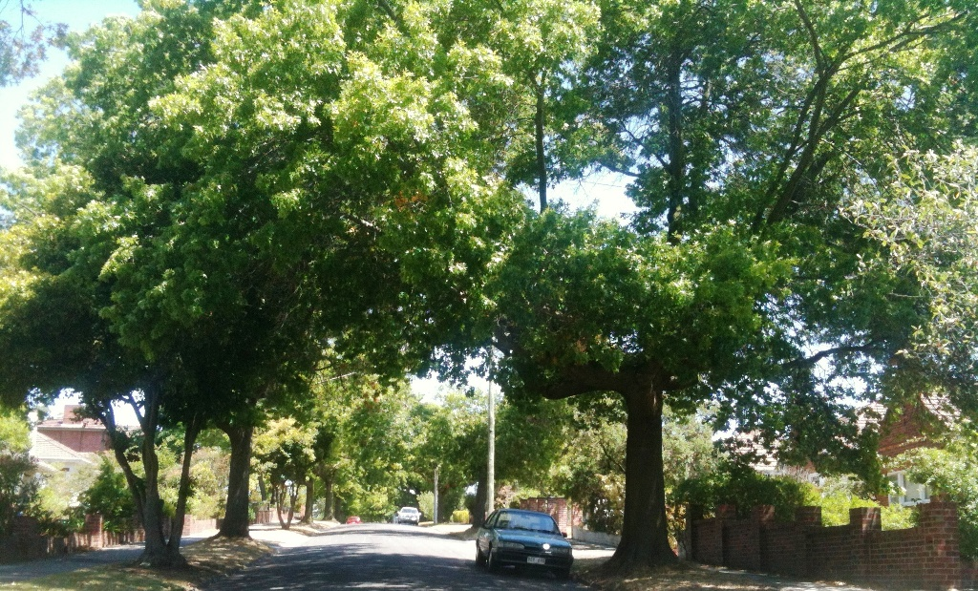

March 2003

www.alexanderurbanism.com

This is a paper presented at the 2003 Planning Institute of Australia national conference. Nathan Alexander and Paul Stark were working at the time for Planning SA, the planning agency of the South Australian Government. One of their projects was preparing a planning guideline on neighbourhood character to assist both the community and local governments in South Australia. Nathan has a background in urban design and has consulted on neighbourhood character for local government. Paul has specialised in heritage management.

1 Introduction
Is the protection of neighbourhood character simply the affluent imposing monocultural norms on an increasingly diverse society? Why are the fiercest debates about change typically generated in suburbs where similar residential stock was built en masse but is now filled with affluent individual resistors of change? Are suburbs with diverse built form more tolerant?
Neighbourhood character is a hot issue with interest groups such as Save our Suburbs being formed to protect the existing character of residential areas. This paper draws on experience in Sydney, Melbourne and Adelaide to examine the issue of neighbourhood character, and what to do about it. We firstly define the term and why it is an issue. We then present key concepts to help analyse and discuss the issue. Finally, we outline a methodology for designers on one hand and local government on the other to address the challenge, based on understanding what the community values.

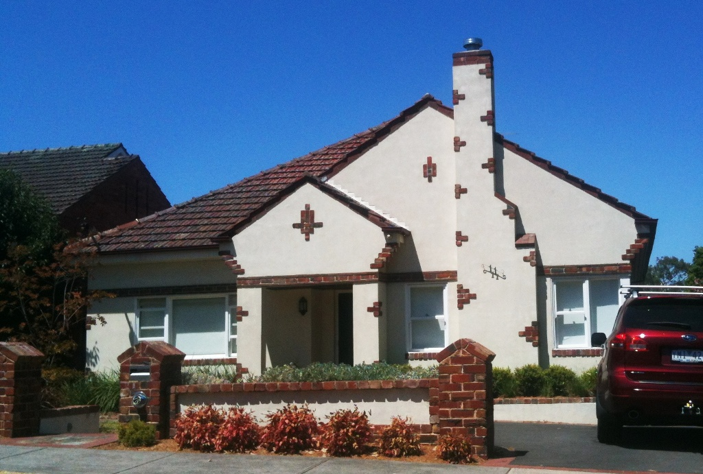

2 Definition and Scope
Neighbourhood character was defined in the early 1990’s by Victoria’s planning officialdom as “the interrelationship of various aspects of built form, topography, vegetation, density, subdivision pattern and activity, both in the public (realm) and private domain”. Put more simply, it is the ‘look and feel of an area’. It includes streets, front yards and private buildings as they face the street, but also back yards and ‘activity’.
This paper limits itself to the physical elements of neighbourhood character although it is acknowledged that patterns of use and activity can be defining aspects of a neighbourhood. While neighbourhood character can be applied to town and city centres, these areas are typically more complex in the age, use and form of buildings than other urban areas. To more clearly illustrate the issues, we have limited ourselves to the primarily residential areas that comprise the bulk of Australian urban areas.
We reject the notion that only some areas have ‘character’. All areas have a character! The character of a neighbourhood is created by patterns of interrelationship of elements that are reinforced through repetition. The character of an area can be seen to fall somewhere on the following spectrums:
- Accidental character to deliberate creation
- Subtle to overt
- Cohesive to eclectic
- Incomplete to complete
- From a single period to from a range of periods
- All trees and shrubs to all buildings
- Not valued to highly valued
Some interrelationships, some patterns, will clearly be more significant in creating this character than others. For example, in many suburban streets, it is the street trees, and sometimes the front gardens, that provide the significant patterns that make the neighbourhood character. Built form, beyond perhaps the front fences, may be irrelevant. At the other extreme, in more urban streets it is the built form that provides the character, even to the extent that some quality urban places have no trees.
Whatever the qualities of neighbourhood character, we believe that many can be objectively assessed.

3 Why bother with Neighbourhood Character?
Concerns for the future character of existing neighbourhoods have arisen mostly in the inner and middle ring suburbs of Australian cities. The appearance of new developments is often quite different from those existing. This has focussed attention on the visual relationships between new and old and the contextual quality of new development.
Typically, new development at higher densities has led to:
- loss of the familiar;
- walls on boundaries;
- more hard paving;
- less front gardens and smaller setbacks;
- shallow detailing;
- strong cubic forms; and
- replacements that tend to be found 'anywhere', but seem not to relate to the existing context.
Headlines of Vanishing Character as well as references to a Tuscan challenge are only two of numerous examples. It would be unfair to characterise concerns about new developments being out of character simply as a fear of change. Communities do value aspects of neighbourhood character, and this needs to be respected, if not always acceded to.
In our view, the debate is occurring because the systems of development control in Australia do not deal well with the analysis of built form or issues of design quality.

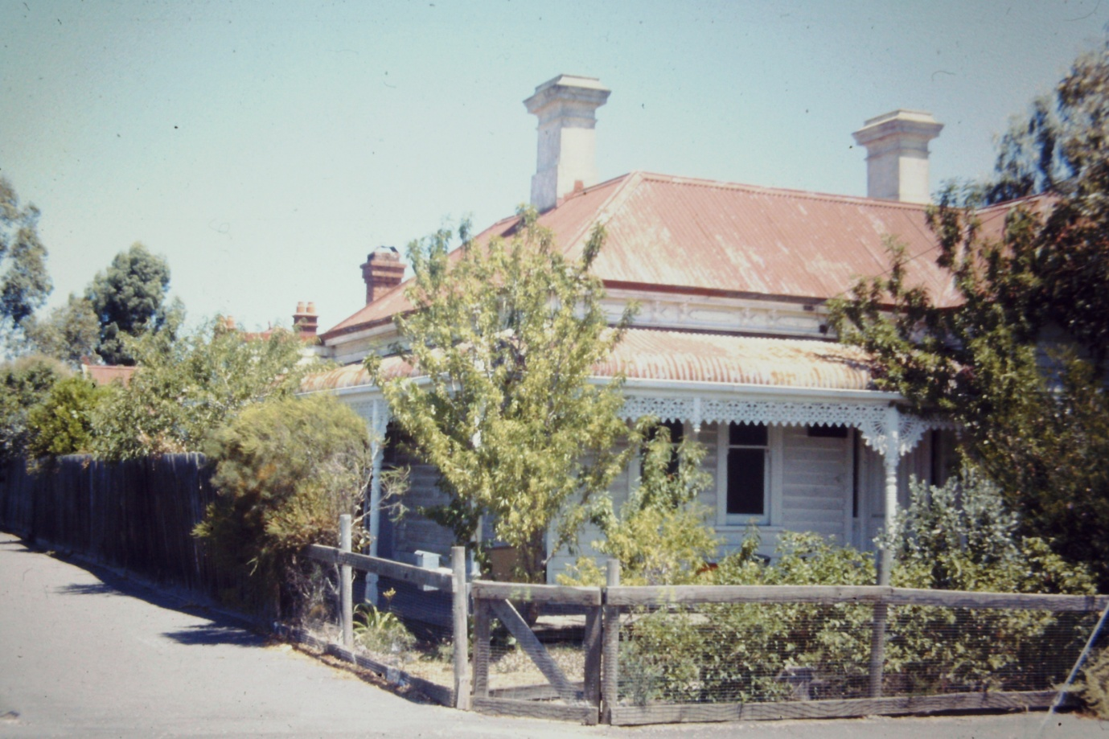

4 Key concepts
We believe four concepts are key to thinking about the subject:
- Neighbourhood character applies to thematic buildings
- Neighbourhood character is distinct from heritage
- Existing character versus preferred character
- The community as client, the proponent as actor and government as director

4.1 Thematic buildings
Most buildings and most streets are thematic, that is, their use and their form are largely consistent with their neighbours. The vast majority of urban buildings are thematic.
While thematic buildings are the Indians in the urban landscape, monumental buildings stand out as chiefs. Because of their use they are important to their community and deserve to stand out from their neighbours. When designers create a monumental building undeserving of its standout appearance and at odds with its thematic setting of housing – an Indian pretending to be a chief – is it any wonder people become concerned?

4.2 Neighbourhood character is distinct from heritage
Neighbourhood character is not a substitute for heritage, or its equivalent. It is a separate though related process for the recognition and management of particular urban qualities. While the management of built heritage is concerned with the security of physical fabric, neighbourhood character is concerned with the valued patterns of interrelationship of various elements. While heritage management discourages the reproduction of architectural styles, in neighbourhood character this may be an acceptable solution.

4.3 Existing character versus preferred character
An important distinction should be made between a description and analysis of ‘existing character’ and ‘preferred character’. Determining the existing character is an exercise in observing patterns of interrelationship, and deciding the importance of patterns in relation to others, for each site and precinct. Determining a preferred character is an exercise in understanding the advantages and disadvantages of a range of possible future characters and agreeing on one option.
In some neighbourhoods, protecting all elements of the existing character is clearly appropriate. Likewise, in others the need to radically change the existing character to something else is obvious. The most common condition is the messy reality in between where some elements deserve to be kept, others changed.
4.4 The community as client, the proponent as actor and government as director
We see three distinct roles for the three main players in the creation of neighbourhood character: the community, the proponent and local government.
The people who live, work and visit a neighbourhood are the users of the product of neighbourhood character, and thus are the client. Whether as professionals we like or don’t like the users’ views of what they value about the character of a neighbourhood, we should be faithful conduits for them.
The body who proposes a development is the proponent, the agent of change. The task for the community is communicating a preferred character for the development of a site to the proponents and their agents, especially their designers.
Lastly, local government mediates between the community and the proponents, transmitting and shaping the community's interests to the proponents. It can determine existing and preferred characters and operate the levers to implement change in both the public domain and the private realm. Local governments can use neighbourhood character strategies to mediate between a designer’s individual conception of a development and the community perceptions of that development through positive design-focussed guidelines and policies.
Identifying a preferred character for a neighbourhood should also guide local government in its public realm works for that neighbourhood. The preferred character should be reflected in any urban design frameworks, master plans, concept plans and design documentation for paving, tree planting and furnishing of streets.

5 Analysing existing neighbourhood character
As the planning authority, local government needs to analyse existing character as a basis to determining a preferred character; proponents need to analyse existing character so that their design proposals respond appropriately to it.

To accomplish this essential step we suggest first examining the neighbourhood at different scales:
- adjacent properties (the view ‘square-on’ to each property)
- character precinct (the view along the street)
- neighbourhood (preceding and succeeding views)

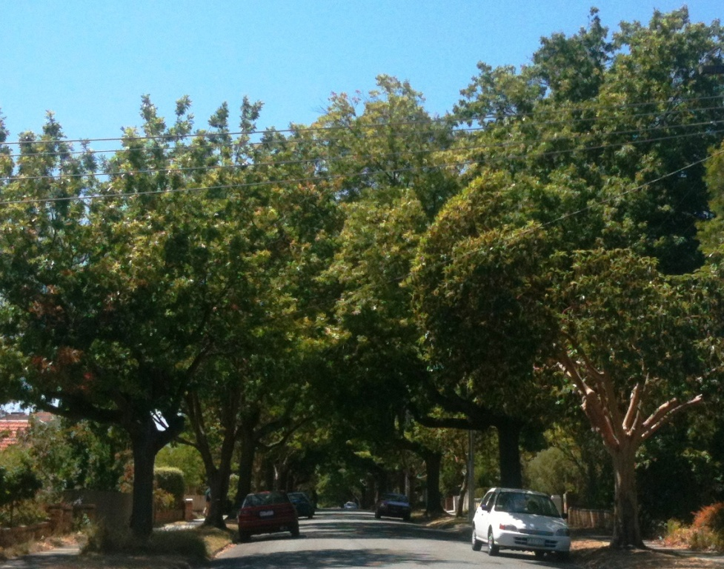
Adjacent properties include those either side of the allotment under consideration, as well as immediately over the street, and in some instances, beyond the rear boundary. An analysis of adjacent properties is essential for the designer to understand the context of the site for which a development is being designed.
By 'character precinct' we mean the fundamental unit of neighbourhood character analysis: those properties that have a strong visual relationship to each other within a street or other urban space. It is typically the view obtained when you turn into a street and encompasses the area from rear lot boundary to rear lot boundary, with the buildings and the street in between, and often extends from one street intersection to the next. In some instances the precinct may be only one side of the street, where each side has a distinct character. Adjoining precincts can demonstrate identical, similar or quite different characters.
Although for the purposes of design and planning, most relevant cues will be found in the adjoining properties and the character precinct, a sense of the wider neighbourhood and its character is also useful.

At each scale, we can examine various elements to see if there are patterns of interrelationship between those various elements, and get a sense of how significant each pattern is. Typical elements to examine are shown in the checklist below, from largest scale to smallest.
Neighbourhood
- topography;
- street pattern;
- axes and vistas across the area;
- the prevailing character of the public realm; and
- the proportion of site coverage;
Character precinct
- trees, furniture and paving of the public realm;
- pattern of lot frontage widths;
- front setbacks;
- height and silhouette of buildings;
- access points;
- fences and walls;
- levels of light and shade found in buildings and grounds; and
- the composition of buildings, including symmetries.
Adjacent properties
- building form;
- direction of building composition;
- the depth of planes and intricacies of line in the appearance of street facades;
- side setbacks;
- the use of solid and void in buildings; and
- colour and texture of materials.
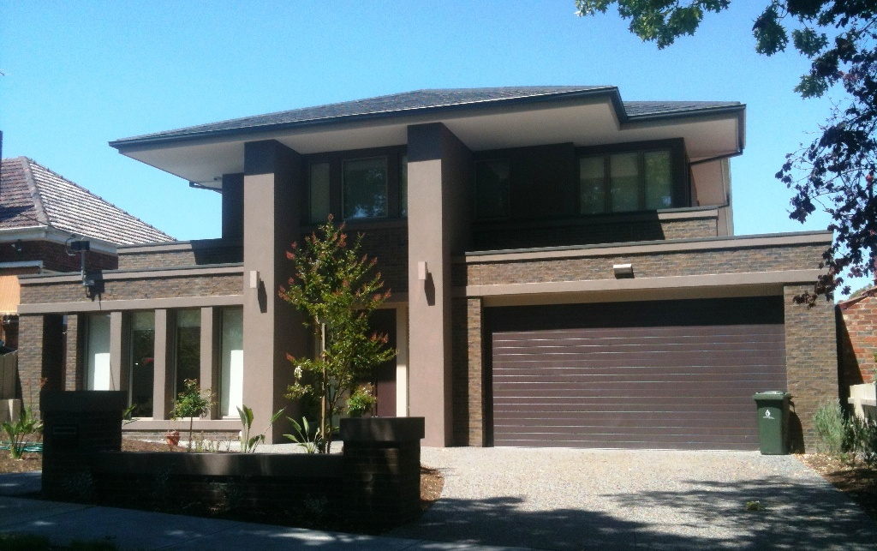
The designer needs to make decisions about the most relevant patterns and scales to respond to. Clear guidance by the municipality on the preferred character, and therefore the design cues from the existing character considered most relevant, will reduce the workload of the designer and give the proponent and the community greater comfort that a contextual design will be achieved.

6 Preparing a neighbourhood character strategy
There is a market for strong cohesive character, as demonstrated in the number of greenfield estates being developed over the last decade with firm design guidelines. These provide prospective buyers with predictability about siting, appearance and general quality of the public and private domains. Likewise there is a market for cohesive character, as often found in the existing inner suburbs. We suggest that state and local development control systems should have the mechanisms in place to protect valued existing characters, or to achieve any other preferred character, so existing communities can achieve what greenfields estates offer.
We therefore believe it imperative for local governments to have a view on the preferred character for each area they administer. This can be as simple as ‘anything goes’ through to ‘exactly as is’. In most cases, it is more likely to be in between. The way to determine and achieve this preferred character is by preparing a neighbourhood character strategy.
This involves the following steps:
- Determine the existing character;
- Consult with the community on what is valued;
- Examine future community needs;
- Propose options for the preferred character;
- Decide on a preferred character;
- Prepare a strategy to achieve the preferred character;
- Implement the strategy; and
- Review the strategy.
Elaboration on the details of these steps is the topic for another presentation. However, here are a few pointers:

Don’t do exhaustive surveys of each element in each property in each street
Exhaustive descriptions of the constituent elements of the matrix of an area are not required. Rather, identify the prevailing patterns and common elements.

Do move through each area to get the sense of the area as a whole
Identification of the prevailing grain, pattern, form and detailing of the existing character is most likely to be revealed when moving through the area. While the typical building descriptors of height, colour and material play a role in assessment, consideration of these alone is likely to limit descriptions to a static view. The urban environment however is usually viewed in the oblique, often in passing.

Do consider issues other than character
Once the value of existing neighbourhood characters has been established and agreed, other issues need to be investigated and resolved before determining a preferred character. For example:
- What housing types will be needed, and how many and where?;
- What uses are becoming obsolete?;
- What can the development industry do and what does it want to do?; and
- Are more jobs needed in the area?

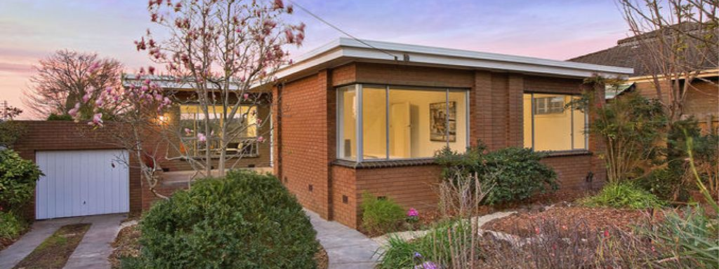

Do debate what is valued by the community
The determination of the community’s preferred character must be part of a wider planning debate. Such debates involve values and different people and groups have differing values. Community consultation strategies need to be carefully crafted for the process to be as representative as possible. It should engage the views of those affected by urban change and those likely to create and assess that change.

Do think about techniques beyond development control
Techniques might include: community champions, design guidelines (real guidelines, not rulebooks!); educational material; workshops to train local designers; discussions between local government staff and proponents’ designers prior to formal application of proposals. Designers can be encouraged to respond explicitly to the context of proposals through the preparation of statements of effect. What is good design in one locality is not necessarily transferable.

Conclusion
Neighbourhood character is concerned with the ‘look and feel of an area’. All areas have a character! The character of a neighbourhood is created by patterns of interrelationship of elements that are reinforced through repetition. These can be identified, as can the relative significance of different patterns. The determination of neighbourhood character is necessary to the consideration of how proposed developments fit with their context, at least when the built form is thematic, rather than monumental.
Systems of development control in Australia typically do not deal well with issues of built form and design quality, and therefore of neighbourhood character. Much new development is out of character, in areas where the neighbours value what they already have. Many ratepayers seem to have expectations beyond the present capacity of their municipality’s development control system.
Neighbourhood character strategies provide a rigorous means of addressing this need. The first step is the identification of the existing character of areas. Then, based on the community’s values about existing character, as well as non-character issues such as future housing needs, a preferred character can be agreed upon.
An analysis of existing neighbourhood character relies on examining patterns of elements - immediately adjacent to the site, in the precinct, and in the neighbourhood.
Neighbourhood character is different from heritage. Heritage controls seek to preserve a building or other physical object. Neighbourhood character strategies seek to enhance valued patterns, and this is primarily done through new development.
If the municipality has already worked with the community to resolve a preferred character, it provides greater certainty for all concerned, and is likely to lead over time to a more loved neighbourhood and higher value real estate.
Without neighbourhood character strategies, media reports of loss of character are likely to re-appear. The translation of neighbourhood character strategies into planning schemes puts local governments and their communities in strong positions to positively manage character in ways other than locking it. Neighbourhood character allows a dynamic balance to the struck between urban quality and the need for urban change.
