Nathan Alexander

Ingredients for a liveable city

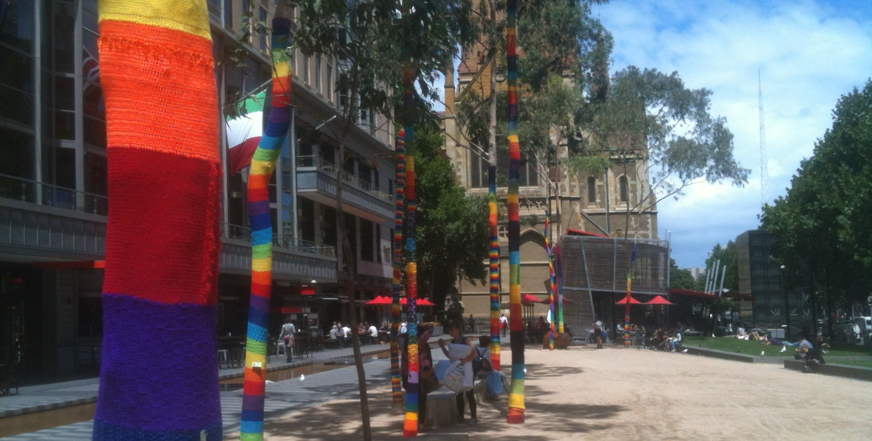

An extract from Places for People: Melbourne city 1994, p.14
Published by the City of Melbourne, ISBN 0 949624 84 5

Based on the writings of Professor Jan Gehl
Professor of Urban Design
Royal Danish Academy of Fine Arts, Copenhagen

1994

Ingredients for an enjoyable walking city
• Paths to walk along free of hazards and congestion.
• A choice of sun or shade, depending on the temperature.
• Protection from rain and strong winds.
• Interesting ground-level facades to stroll beside and observe.
• Easy, safe access for people with disabilities.
• An easy-to-understand pedestrian network that people can find their way through.
• Places to promenade and places to rest.
• A pedestrian system that connects important destinations.
• Few intersections where people must wait a long time to give way to vehicles.
• Well-lit places and routes to walk around that are safe both day and night.
Ingredients for a city where people enjoy staying outside
• Space for standing, sitting, playing and talking.
• People to watch.
• A choice of sun or shade, depending on temperature.
• Shelter from the rain and strong winds.
• Interesting ground-level facades adjoining spaces where people congregate.
• Residences, workplaces, recreational and social facilities well mixed together.
• Comfortable outdoor spaces to stay in with three types of seats:
1. Well-placed public seats
2. Well-placed outdoor cafes
3. Widespread secondary seating, such as steps and planter box edges.
Ingredients for a city with a high level of social and cultural exchange
• Space for street theatre, clowns and jesters, music and small-scale commercial activities.
• Space for people to sit together outside.
• Public spaces free from loud traffic noise or physical threat.
• Ground-level building facades that provide interest through windows, displays and visible indoor activity.
Ingredients for a city where people feel safe around the clock
• Other people on the streets.
• A wide variety of land uses mixed together, such as shops, offices, schools and dwellings.
• Many interesting display windows, visible in the daytime and lit up in the evenings.
• Housing to ensure a lively city day and night, not just during working hours.
• Schools and universities, for the life and vitality students bring.
• Beautiful and effective lighting.
• A mixture of daytime and night-time functions.
• Clean and cared-for streets.
Ingredients for an interesting and attractive city
• Diverse people.
• Beautiful spaces, wonderful views.
• Good visual qualities, from small details to streetscapes and vistas.
• Valuable historic environments retained, respected and interpreted.

