Nathan Alexander

Valuing our significant urban places
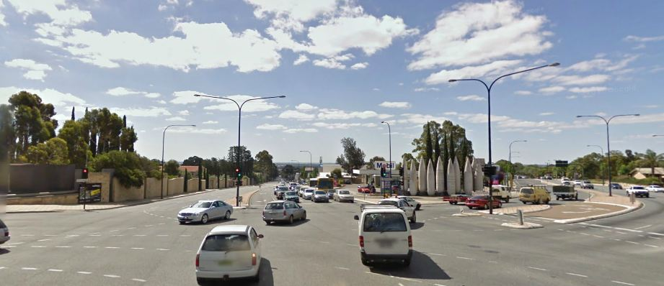
Glen Osmond Gateway, South Australia Image by Google Street View

January 2004

www.alexanderurbanism.com

Recent market research conducted for Planning SA found that Adelaideans clearly value being able to get around, but the places they occupy and visit are not highly valued except as a backdrop. In my experience, Australians have little conscious awareness or understanding of the urban environments that most of us live in.
How can we better value these places? One idea I have been toying with recently is to list the top one hundred urban places throughout South Australia in a Significant Places Register. A citation for each place would explain the existing qualities that give it significance, and the characteristics to be retained or enhanced in any development there.
A citation stating a place’s important qualities and characteristics is a useful step to reaching community agreement on what is valued, what to retain and enhance, and perhaps characteristics to be removed or diminished.
At the moment Australian governments rightly devote much effort to protecting buildings and other objects from past eras to help keep the past alive as an educational resource. This is one form of ‘heritage’, which in its broadest sense is that which is worthy of passing on to future generations. Likewise, it would be worth having government put effort into understanding which public places are most valued by the community for their current contribution to our daily lives, and that are worthy of passing on to future generations with their valued characteristics at least retained and preferably enhanced.
A site might make the list if it fulfils all of the following criteria:
- An individual place, typically able to be seen in totality from one point within the place
- Clearly ‘public’ in its use, ownership or visibility
- Experienced by a large proportion of the residents of the region in the course of routine activity, either by moving through it or by viewing it
- Assessed by expert opinion as of state significance for its existing or potential qualities

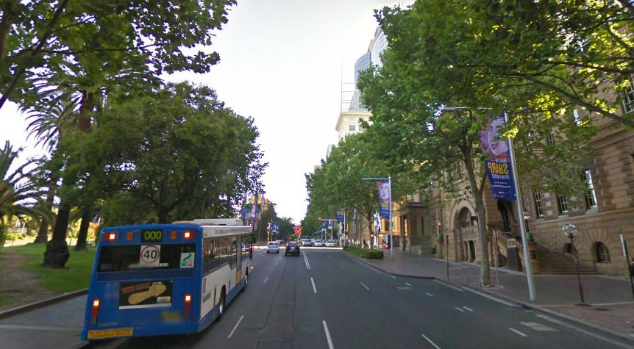
Macquarie Street, Sydney Image from Google Street View

The qualities that will typically lead to an assessment of significance include:
- Playing a major structural role in the region’s layout, for example, St Kilda Junction in Melbourne
- Being of unusually high quality, for example Macquarie Street, Sydney
- Including locally typical forms, materials, colors and or construction techniques, for example, the bluestone walls at the Glen Osmond Gateway, Adelaide
- Accommodating an unusual public function and or activity, for example, Salamanca Place, Hobart
- A strong spatial experience that is unusual within the region, for example, the transition between the Adelaide Hills and the Adelaide Plains at Gorge Road.

An agreed method to identify public places of state significance and their important characteristics would be useful to public bodies that manage, regulate or alter public spaces. Using an agreed method these public bodies would know where to use higher standards of care, management and design, and the particular qualities to be retained or enhanced. New works in places such as Gepps Cross in Adelaide, St Kilda Junction in Melbourne or the Kings Cross interchange in Sydney deserve better than a standard highway treatment or a building on a backstreet.

The purpose of listing places on the register would be to seek to influence the actions of state government agencies when altering the publicly owned parts of the place, typically the ground plane, and to influence the actions of private landowners when changing their property, typically the buildings that enclose the space, by using local government’s development regulations.
The Heritage Registers maintained by each state are an excellent model for a Significant Places Register. While the heritage register concentrates on the qualities to be maintained by heritage places, a state register of significant public places would concentrate on the qualities to be achieved in the future.
Which Australian state will take up this idea first?

