Nathan Alexander

The qualities of Hanging Rock

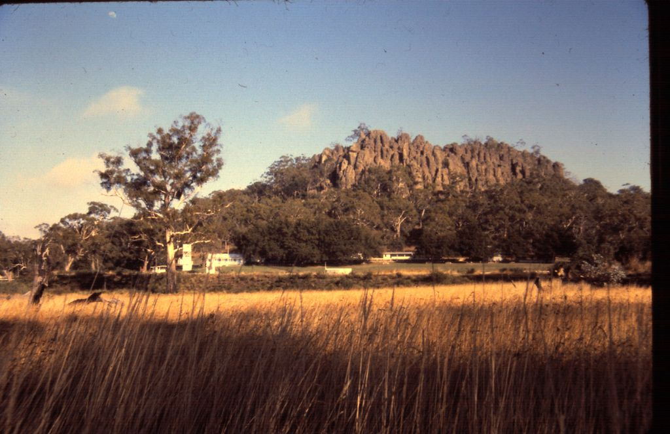

An extract from Spirit and Earth: setting the scene for experiencing Hanging Rock, by Nathan Alexander, November 1985, self-published.

This work was undertaken to complete a Bachelor of Applied Science (Landscape Architecture).

November 1985

Below are described the sixteen main qualities that people experience when visiting Hanging Rock. Together they create an experience rarely encountered, and one that cannot be even closely imitated by any media. Many famous places have been exposed to the public so often in the mass media that when it is seen in reality one feels one has seen it all before. Hanging Rock is a place that requires one to experience it in the round and with the five senses.

1. Lack of Reference

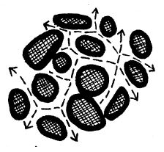
From within the Rock the irregularities of the pinnacles and their clustering creates an impression of chaos. The forms of these spaces and objects are so numerous and so defy easy categorization that they soon all look alike to the newcomer. Most of the Rock is a series of spaces visually isolated from all but a few others, making it hard to see where one has come from or where one is going. In many places there is no view to the surrounding countryside to allow orientation. The strange and numerous forms, the short sight lines, and the lack of views to the outside add up to a lack of reference points with which to direct oneself.
The situation is compounded by the lack of a clear movement sequence over the Rock. The Rock is called trackless, but it is actually the reverse. In many places the tracks lead off in all directions that allow footholds. The confusion is assisted by many 'tracks' that are actually water channels that lead nowhere except to sudden drops. Having tracks everywhere is equivalent to no tracks at all, making it easy to get lost. Even people who know the Rock well can become disoriented in some areas. This makes the Rock confusing if a particular goal is being sought, but excellent if one is just wandering.
The lack of reference points and the lack of a clear sequence of movement has a property additional to people becoming lost easily. Moving through a space where one has been before and not recognising it is highly likely. This enables people to experience a previously visited spot as a new place several times.

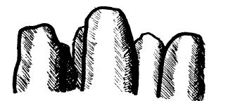
2. Vertical Emphasis

Unlike most landscapes, Hanging Rock has a vertical emphasis created by the multitude of pinnacles and the steep sides of the mamelon. This contrasts strongly with the horizontality of the surrounding plain.

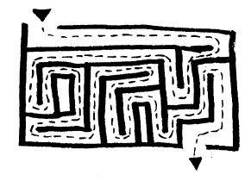
3. Spatial Complexity
Because of the size of the Rock, the short sight lines, the irregular distribution of the pinnacles, the many changes of level, and the inability to obtain an overview of the Rock, it is spatially very complex and offers a large number of places to explore.

4. Large Scale

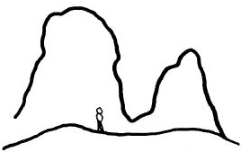

Humans are small in comparison to many of the elements of the Rock. The pinnacles and the cliffs are so large that they become abstract and sculptural.

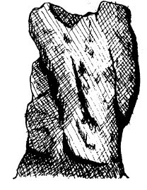
5. Stone as the Dominant Material

On many parts Of the Rock, stones are almost the only part of the composition. Where trees are present, they are mostly very obviously affected by this dominance. Rocks long outlast other natural materials such as plants and animals. Compared to humans and human creations, stone endures virtually unchanged over centuries. Because stone is the dominant material at Hanging Rock, the character of the place is much less changeable and is more enduring than most other natural environments

6. Detachment

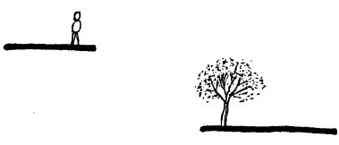
In most places the view from Hanging Rock to the surrounding country is like an aerial view. One is vaguely conscious of the immediate foreground, and also of the background, but the middle-ground is missing. Because of the abrupt rise of the Rock one cannot see any connection between the viewing point and the view. This gives a sense of separation, of removal.
It is unlike most mountain lookouts. At places like Mt Macedon or Mt Dandenong one is aware of the plain rising to meet the lookout. In areas like the Grampians, although the drop is often very severe from the viewing points, one's position is explainable by the similar formations one is viewing. At the Rock, one seems to be detached from the plain, in a world removed from that around it.

7. Ability to Absorb Many People

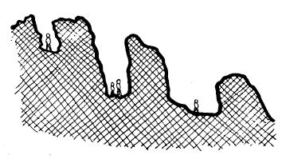

Hanging Rock is in quiet surroundings, and is visually removed from it. Its spatial complexity means that there are many places out of view and out of earshot of most other places on the Rock. Because of its large size, it is possible to have many people on the Rock who have little contact or even awareness of the others there.

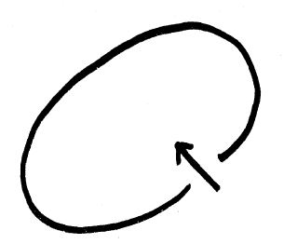
8. Hazardousness
All over Hanging Rock there are cliffs, crevices, holes, dead ends, slippery spots and projecting rocks ready to injure the foolish or the unaware. These hazards are easy to avoid, but one is constantly conscious of them, and must learn to handle them in order to explore certain parts of the Rock.
9. Definite Boundaries
As with a walled city, the Rock offers the distinct experience of being inside a clearly defined place. Without a doubt one knows where the edges of the Rock are, and whether one is inside or outside.

10. Naturalness

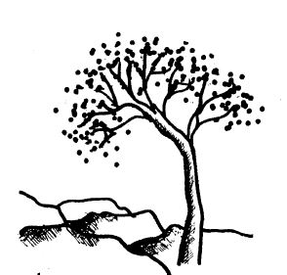
The Rock is patently non-human. It lacks the regularity, uniformity and design for a particular purpose that mark out human creations. The vegetation and the stones remind people that life goes on without humans. Deliberate adaptation of the Rock to suit people is minor, consisting of a few pathways and some steps, handrails and bins. The effects of people are larger, including most paths, erosion, trampling of vegetation, litter and graffiti. Many of these human elements are mostly unnoticed, such as the paths. Things that are unmistakably human are very obvious to most visitors, e.g. handrails, litter, and other people.

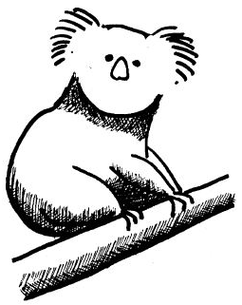
11. Wildlife
Apart from the Rock the Reserve provides a place in which to see some of the endemic plants and animals of the area, especially the koalas and black wallabies.

12. Views

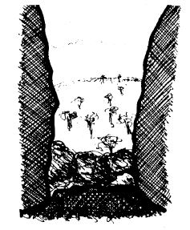
On the Rock the observer is constantly looking around pinnacles or through crevices and holes at other pinnacles, crevices and holes; or beyond to the sky and the surrounding country. This framing of the view heightens the drama of looking, and emphasizes a sense of removal and depth. The irregularity of the frames creates a constantly changing image as one moves about the Rock. On much of the Rock views are totally internal, often confined to small areas. Views to the outside are possible only in certain spots, and then usually broken by pinnacles in the foreground.
As a lookout, the Rock allows visitors to the region to get a sense of the entire area that they have come to. The people who live nearby can do so too, to reassess the shape and scope of their surroundings.

13. Wealth of Detail

The Rock displays wealth of visual and tactile detail: slight variations in rock colour; the different patterns and types of surface markings; the changing colours of the mosses and lichens; the many shapes of the rocks, with their cracks and hollows; exposed tree roots twisting out over rounded rocks; the diversity of spaces, some intimate, some grand, and none the same; and much more besides. The Rock is not just a monolith but is composed of many small elements that together sensually engage a person. People can touch things, feel them, smell them. The hand and the eye always have a lot to hold. Repeat visits reveal the variation in the colour of the rock under different lights, of the wind under different skies, of the grasses during the different seasons. The wealth of detail makes the Rock a sensuous place.

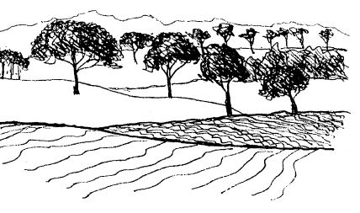
14. Pastoral Surrounds

The country around the Rock is mostly pastoral. It allows open views over gently undulating ground and through scattered trees. Being farms or large residential blocks the locality is very quiet, the main sounds being from vehicles and the occasional chainsaw.

15. Dominance of the Landscape

Within a radius of several kilometres the Rock is the dominant feature. Both in the Reserve and around it, one is aware of the presence of the Rock even when it is hidden behind trees or a low rise. This dominance is achieved partly because it is a high point in the landscape, but also because it looks such an anomaly, being solitary and rising so suddenly from the plain. In the picnic grounds even though in many places one cannot actually see the Rock, one is constantly aware of its presence because of the ground rising to meet it and because of one's recall of previous sightings.
As a landmark the Rock gives people a place which they can see from far away and by which they can orient themselves.

16. Buffer Zone

The ring of forest around the Rock acts as a visual signal that the Reserve is not part of the usual land-use of the locality. More importantly it provides a quiet natural belt of vegetation which is the essential setting for the principal attraction, the Rock.

