Nathan Alexander

The evolution of metropolitan Adelaide
Extracted and adapted from Appendix 1 of 'A distinct advantage: strategies to enhance the structure and character of metropolitan Adelaide', a report written for the Government of South Australia.
October 2004

www.alexanderurbanism.com

Before 1836: a natural structure
The Adelaide region offered a variety of environments for human use. Most of the area was lightly wooded, with the dominant tree species, red gum and peppermint gum, widely spaced among grasses and other understorey plants. Along the many intermittent watercourses the tree spacing became much denser. Between Glenelg and Adelaide lay a forest of gums, native pine (Callitris spp.) and thick understorey that was aptly called the Black Forest. Native pines also grew thickly in the West Lakes and Enfield areas. Grass trees were common along the foothills, and fruit-bearing trees such as the quandong and native cherry were widespread. Coastal sand-hills grew sheoaks, gums and acacias. Behind the dunes, extensive areas of swamp and reedy marsh drained into the mangrove-lined estuaries of the Port and Patawalonga river systems.
Aboriginal groups probably occupied the Adelaide area for at least ten thousand years. Immediately prior to European settlement in 1836 the Kaurna people occupied the region. They consisted of several mobile groups, and possibly numbered no more than three hundred people within the Adelaide district. Their territory extended north towards the head of Gulf St Vincent and south towards Cape Jervis.

1836-1839: Laying a structure for settlement
In 1834 the British Government passed an act to establish a colony in the area now known as South Australia. Colonel William Light was appointed as the colony's Surveyor-General, and was given instructions to proceed to the new colony and determine the site for the first town. In 1836, after examining several other possible locations on the coast, Colonel Light choose a site on the east side of the Gulf St Vincent as the location for the capital of the new colony. He conceived of a main settlement ten kilometres inland on high ground besides the River Torrens, roughly mid-way between the hills and the coast, and a subsidiary settlement at the harbour on the Port River.
In 1837 Light completed his design for the town of Adelaide. This design provided 1042 one acre lots, arranged within three small street grids to the north and a larger one to the south, and contained on all sides by parklands. The layout was based on a few simple elements: rectangular street grids with formal squares, streets and encircling Park Lands, all generously proportioned.
Light's Surveys A and B of allotments and roads over the remaining area of the Adelaide Plains, the Willunga Basin and the hills between, occurred between1837 and 1839, and was published posthumously in 1839. The design was based on three simple principles:
• major roads, typically two chains wide (over 40 m), connecting the street grids of Adelaide and North Adelaide with the port, Glenelg, and along either side of the Torrens upstream from the city. (Port Road was surveyed as three and a half chains wide (over 71 m) to provide space for a future canal.)
• a series of north-south roads, one chain wide (over 20 m) and one mile (1600 m) apart, running from Grand Junction Road in the north and to Sheidow Park in the south, with a break at the Torrens River; and
• with the exception of Grand Junction Road, Richmond-Greenhill Roads, and Cross Roads, a series of largely short-run east-west roads, also one chain wide, linking the north-south roads.

Colonel Light's proposed road pattern for the Adelaide Plains
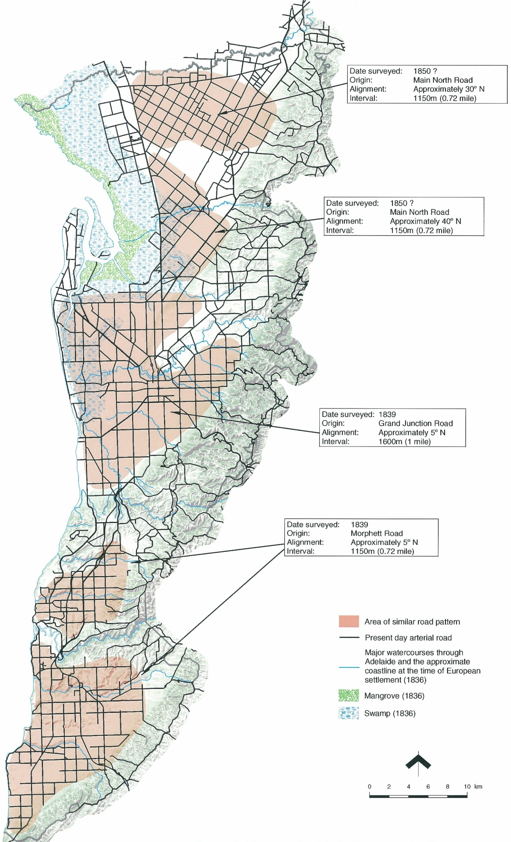

Road grids within metropolitan Adelaide
This survey established the outer boundaries of the Park Lands and the routes through them. Unlike all other routes, Light designed these routes as curving alignments, sometimes indirectly between points, presumably with picturesque intentions.
Surveys A and B became the armature upon which urban and agricultural settlement occurred. It has accommodated the ongoing suburban expansion and the rise of motor traffic. With only minor modifications, it has remained the foundation of the structure and character of Adelaide.

1840-1899: Overlaying more structures
In the 1840's an overland route was created running south-east from the town towards the south-east of the state and Melbourne, presumably close to the route of the present Glen Osmond Road. A route north to Gawler and beyond struck off across the open countryside at Gepps Cross, extending the Main North Road.
Some time later the area between Grand Junction Road through to the Gawler River was surveyed and released for sale. Roads were laid out aligned parallel and normal to Main North Road.
By 1840, over six thousand colonists lived in Adelaide. Those parts of the City of Adelaide close to the River Torrens were the first to be developed, as the cost of water delivery was an important locational consideration. North Terrace attracted government uses and the well-to-do who wanted a pleasant outlook to the river. Commercial development quickly focused on Hindley Street and Rundle Street, being close to the Port and a water supply, but with cheaper land and more passing trade than North Terrace.
By the late 1850s, Adelaide began to assume a more substantial appearance. Natural stone was abundant and widely distributed. High quality bluestone, sandstone, limestone, marble and granite were used in public and commercial buildings. As a result, many buildings from this period still remain. Wood was banned as a construction material within the City of Adelaide for fire safety. The use of brick and stone set a pattern for later suburban development. The prevalence of stone construction in Adelaide's nineteenth century housing distinguishes Adelaide from other Australian cities.
The period between 1870 and 1884 was the most prosperous the colony had known, with the population more than doubling. In the building boom between 1875 and 1882, the typical residence was a fully detached symmetrical double-fronted brick villa, with a decorative stone façade, a corrugated iron roof and verandah.
Because speculation drove up the price of land within the surveyed town, labourers and artisans created a demand for cheaper rural land beyond the Park Lands. In the 1840's speculators subdivided rural sections to create some thirty villages along traffic routes or near water supplies. These villages formed nuclei for later suburban expansion.
By the 1870's boom the areas immediately beyond the Park Lands had been subdivided, including parts of Bowden, Brompton, Hindmarsh, Hackney, Kensington and Norwood. Other areas further out such as Port Adelaide, Marion, Plympton, Lower Mitcham, Unley Park, Parkside, Magill and Walkerville had also been subdivided. To the north-west of the City of Adelaide the road and railway to the Port encouraged urban development, especially of industries. Good clay for brickmaking was found in the Hindmarsh area, and several small industries processing raw materials were established. Along the coast several small townships were growing - Glenelg, Brighton, Henley and Grange. The boom led to massive subdivision between these nuclei, especially in what are now the inner southern and eastern suburbs. After the 1884 depression much of the land remained vacant for decades.
Figure 55: The extent of the metropolitan area c. 1880
In 1852 the first rail service began, running from Adelaide to Salisbury, joined in 1856 by the line to the port. The Adelaide terminus was built on the parkland on North Terrace, so as to be as close to the heart of the town as possible. Parliament House blocked the railway and terminus from being nearer King William Street. This terminus became and remains the main rail station for the entire metropolitan area.
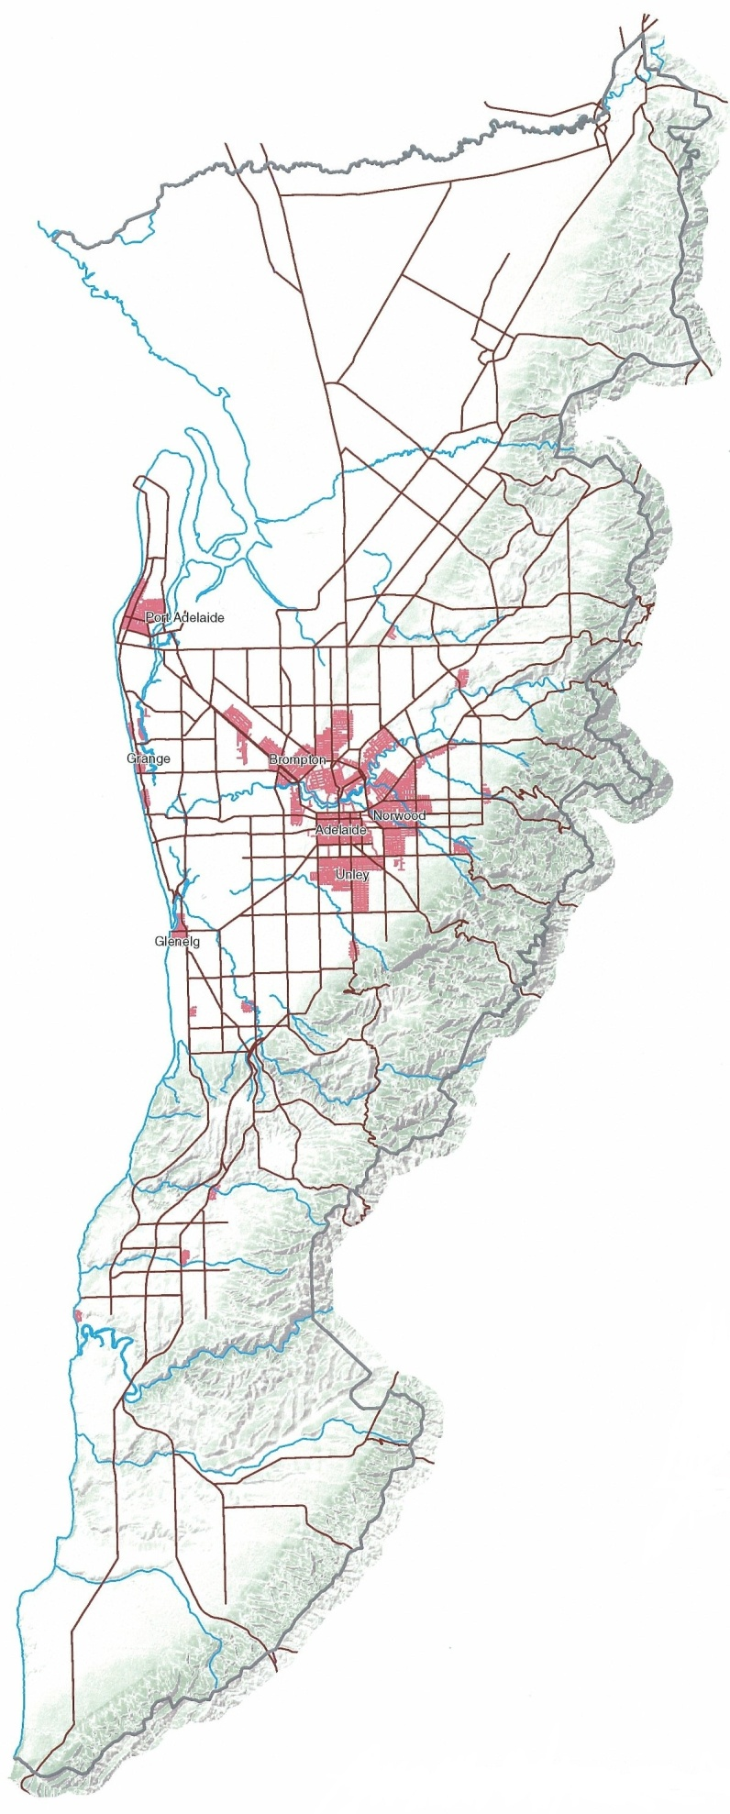
The boom years 1878 to 1884 saw the introduction of horse tramways, further encouraging suburban building and land subdivision. Lines created at this time include those extending from Adelaide to Norwood, Mitcham, Henley Beach, Parkside, Goodwood, Nailsworth, Paradise, Magill and Burnside. An economic depression and the introduction of the bicycle deflated the building and tramway boom.
The railways laid a curvilinear network over Light's largely orthogonal road network, while the tramways followed existing roads.
Between about 1880 and 1900 a reticulated water supply and sewer mains were supplied to the entire urban area, and thereafter largely kept up with urban development, neither acting as a brake or an inducement. Electricity and electric street lighting followed shortly after 1900, when electric street lamps were erected in King William Street. The placement of these underground and overhead services was flexible enough not to shape development of metropolitan Adelaide in any way, either in the location of new suburbs or the width or route of new streets.

1900-1945: Filling Light's structure
By 1900 the population had reached 160 000. South Australia enjoyed a building boom between Federation in 1901 and the First World War. The typical residence was a fully detached asymmetrical bungalow, often with ornate timber detailing and increased articulation of the roof form.
The cost of dredging the Port River for ever larger ships led to the construction of the Outer Harbor, which was opened in 1908. In 1909 the first electric trams replaced the horse-drawn trams.

The extent of metropolitan Adelaide c. 1880
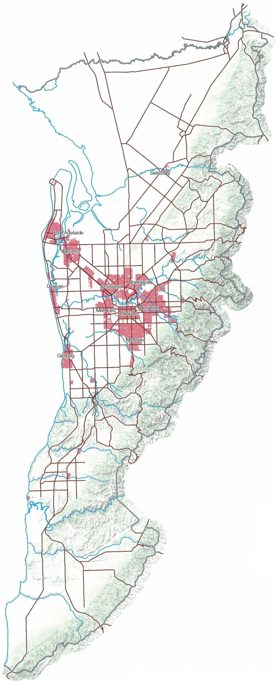
At the outbreak of the World War I urban development extended fairly continuously for a distance of three to five kilometres beyond the Park Lands, with an almost continuous strip of development about 1600 metres wide extending north-west to the Port and Semaphore. Henley, Grange, Glenelg and Brighton were still separate communities along the coast, linked to the city by tram or
By 1919 the population had grown to 250,000 people. From the early 1920's through to about 1928 another building boom was under way. Substantial peripheral expansion occurred, especially on the better-drained land to the south and east of the city, while an urbanised 'corridor' through Woodville linked the city with Port Adelaide. At this time Colonel Light Gardens (formerly Mitcham Gardens) was developed, the first of South Australia's many 'garden suburbs'. A fully detached "Californian bungalow" was the predominant style, usually with a prominent gable to the street frontage incorporating a veranda.
By this time private cars, although not prevalent, had become a common form of passenger transport in Adelaide. The construction of a hangar for civil aircraft at Parafield in 1927 marked the start of regular civilian air services.
Oblique aerial view of the heart of Colonel Light Gardens
Oblique aerial view of Colonel Light Gardens
Residential building in the Depression years of the 1930's through to the end of World War II became a State concern, with direct intervention through the '1000 home scheme', the State Bank Bungalow design and the beginnings of the South Australian Housing Trust in 1936.

The extent of metropolitan Adelaide c 1920
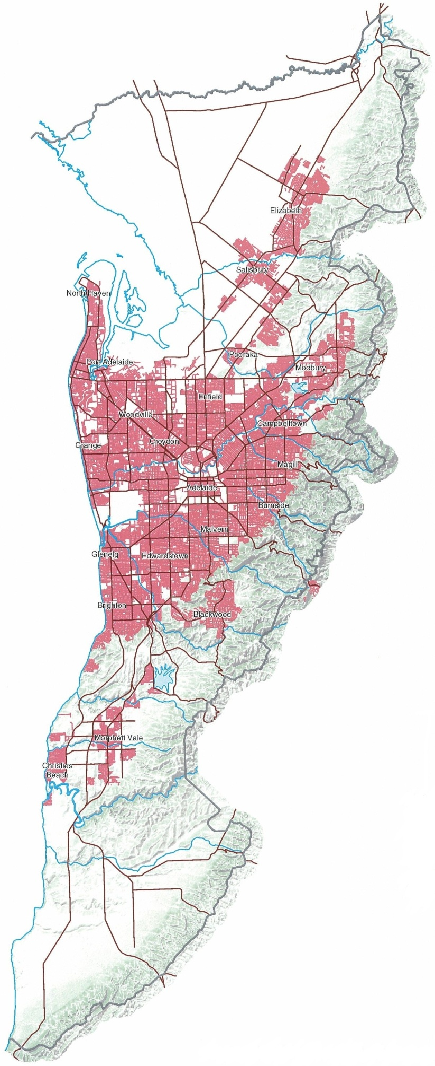
Residential building in the Depression years of the 1930's through to the end of World War II became a State concern, with direct intervention through the '1000 home scheme', the State Bank Bungalow design and the beginnings of the South Australian Housing Trust in 1936.
At the start of World War ll 325,000 people lived in Adelaide. During the war domestic building came to a standstill, but there was rapid industrial development to manufact-ure equipment and supplies for the war effort, which saw a further concentration of industry in the North-West. The Glenelg Road was rebuilt at this time and renamed Anzac Highway. The Department of Defence compulsorily acquired land at Edinburgh (now the Defence Science and Technology Organisation (DSTO) land), to develop a military airfield. Existing public roads over the area were closed.

1945-1989: Expanding beyond Light's structure
From the end of World War ll until late 1970's Adelaide experienced one of the most vigorous and prosperous periods in its history. The expansion of industry and the arrival of large numbers of migrants led to the rapid extension of the metropolitan area well beyond Light's Survey B. Car ownership for adults became nearly universal.
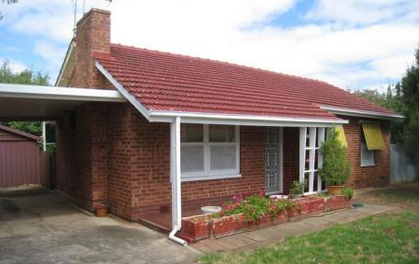A post-war austerity house

The extent of metropolitan Adelaide c. 1960
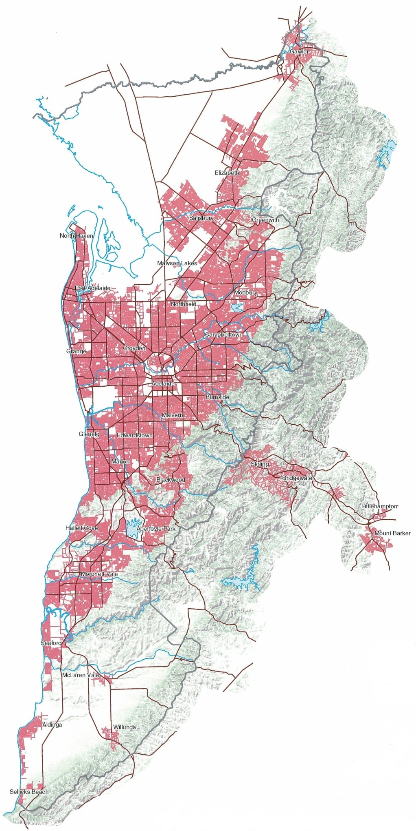
Shortages of materials and their rationing, from 1945 until the early 1960's, led to 'austerity' housing, simple hipped-roof brick bungalows with concrete porches and steel-framed windows.
The South Australian Housing Trust continued to provide low-cost housing for industrial workers, and expanded its role to assist in industrial development. The SAHT became the government's instrument for urban development, housing construction and industrial location during Premier Play-ford's program of large-scale industrialisation.
Initially the Trust's housing stock was built in clusters near public transport. However after 1950 the SAHT began undertaking larger scale projects, notably the satellite town of Elizabeth, which ex-panded in the late fifties in association with the new GMH car plant. The area already had a grid of roads at approx-imately 1100 metre intervals to service the existing agricultural uses. This grid followed the orientation of Main North Road. This and other roads near the town centre were realigned to become curvilinear, while the remaining roads be-came urban arterial roads.

The extent of metropolitan Adelaide c. 2000
By 1955 the digging of the Torrens Outlet had drained the marshes behind the coastal dunes between the Port River and the Patawalonga and a large area of flood prone land further inland. The inland land was large enough to accommodate new runways and a passenger terminal. In developing Adelaide Airport, Morphett Road, which extended north as far as Henley Beach Road, was truncated.
As development reached the foothills of the Mount Lofty Ranges, it became evident that measures should be taken to limit subdivision of land that could not be economically provided with water and sewerage, and legislation to achieve this was passed in 1955(?).
By 1960 the city's population was over 600,000 people. The urban area extended continuously from the foothills of the Mount Lofty Ranges to the sea. Development was rapidly extending north with the building of Elizabeth, to the northeast along the fertile land of the River Torrens towards Modbury, and south over the foothills towards Reynella and Noarlunga.
The concentration of industry in the north-western suburbs was recognised as a problem. Elizabeth was already providing an alternative location for industry to the north, based on the GMH car plant. Industry was also encouraged to move into the southern suburbs, centred around the oil refinery at Port Stanvac, started in 1960, and the Chrysler car plant at CloveIly Park.
The rapid expansion of the urban area, the location of industry and other concerns led to calls for a plan to cover the entire metropolitan region. Such a plan arrived in 1962 — the Report on the Metropolitan Area of Adelaide. Important recommendations implemented from this report included:
• The establishment of more efficient controls on urban development
• The designation of specific areas of rural land at the northern and southern margins for future urban growth; and
• The creation of six regional centres, namely Elizabeth, Salisbury, Tea Tree Gully, Port Adelaide, Bedford Park and Noarlunga.
About 1970, the SAHT developed the proposed new regional centre at Noarlunga, along with surrounding residential suburbs. The area already had a grid of roads to service the existing agricultural uses, at approximately 1100 metre intervals and oriented to the cardinal points. Like Elizabeth, major roads were realigned around and through the town centres to become curvilinear. At the same time, the wetlands at what is now known as West Lakes began being converted to new suburbs by a private-state joint venture development company, which set the pattern for future large-scale urban residential developments such as Golden Grove and Seaford.
The 1962 plan and the 1968 Metropolitan Adelaide Transport plan advocated the creation of a network of freeways throughout the metropolitan area. Land was acquired, but no freeways built. This land, which blighted several inner suburbs, became a de-facto land bank for many urban renewal projects in the 1990's. A freeway through the Hills was opened in 1972 to service the traffic from the south-east of the state and Victoria, as well as a proposed satellite town of Monarto.

1990-2003: Consolidation
In the final decades of the 20th century population growth slowed and large-scale industrialisation ceased. Growth of the urban fringe was constant, fuelled by major transport projects, including the O-Bahn to Modbury and Southern Expressway to the south, as well as a continued increase in personal mobility. Urban growth continued outward to Golden Grove, Seaford and Mt Barker.
From about 1990, with Adelaide's population passing the one million mark, demand in the housing market broadened due to demographic changes and experience of housing choices interstate and overseas. While townhouses and apartments were constructed in central high-amenity locations, houses on the fringe grew larger.
Urban consolidation began about this time when the state government recognised the cost of continued fringe expansion. Consolidation occurred through scattered 'two-for-one' infill and redevelopment of redundant industrial and institutional sites. As with West Lakes, other large greenfields sites surrounded by urban development but overlooked in the first wave of urbanisation, such as Mawson Lakes, were also now developed. Redundant Housing Trust estates, such as Hillcrest and Mitchell Park, were also comprehensively redeveloped. In 2002 the government acted to prevent further expansion of the urban area by enacting an urban containment boundary around metropolitan Adelaide.
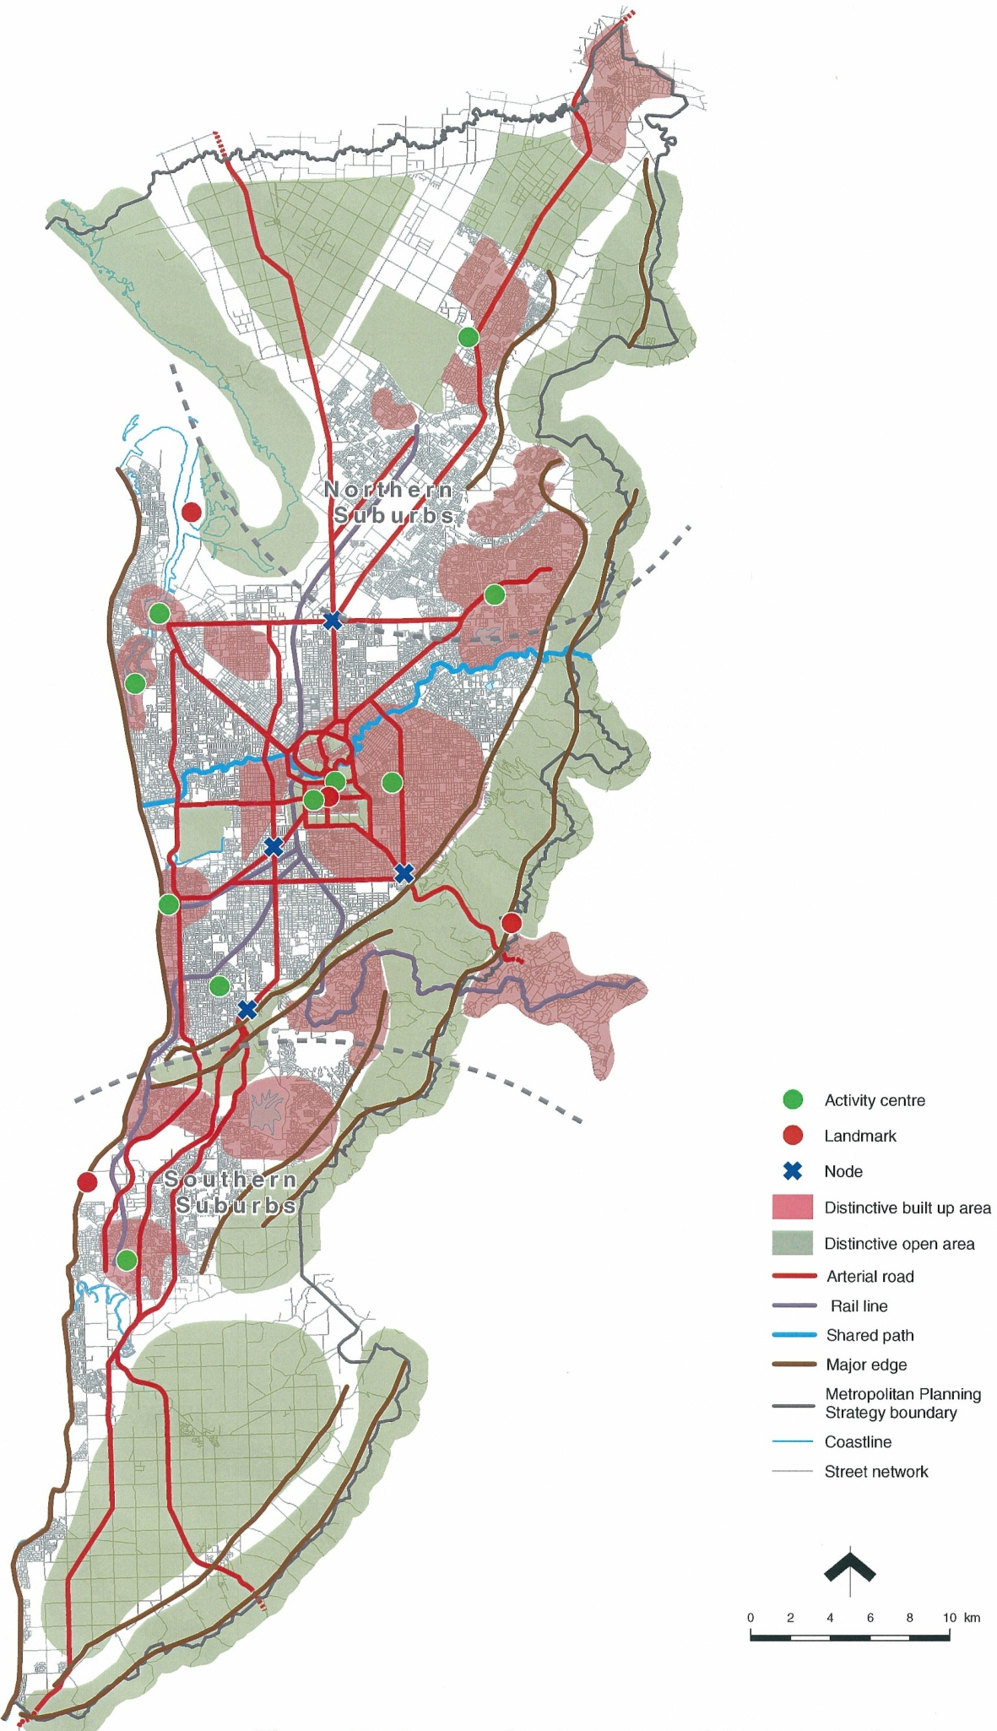
The perceived structure of metropolitan Adelaide, 2003
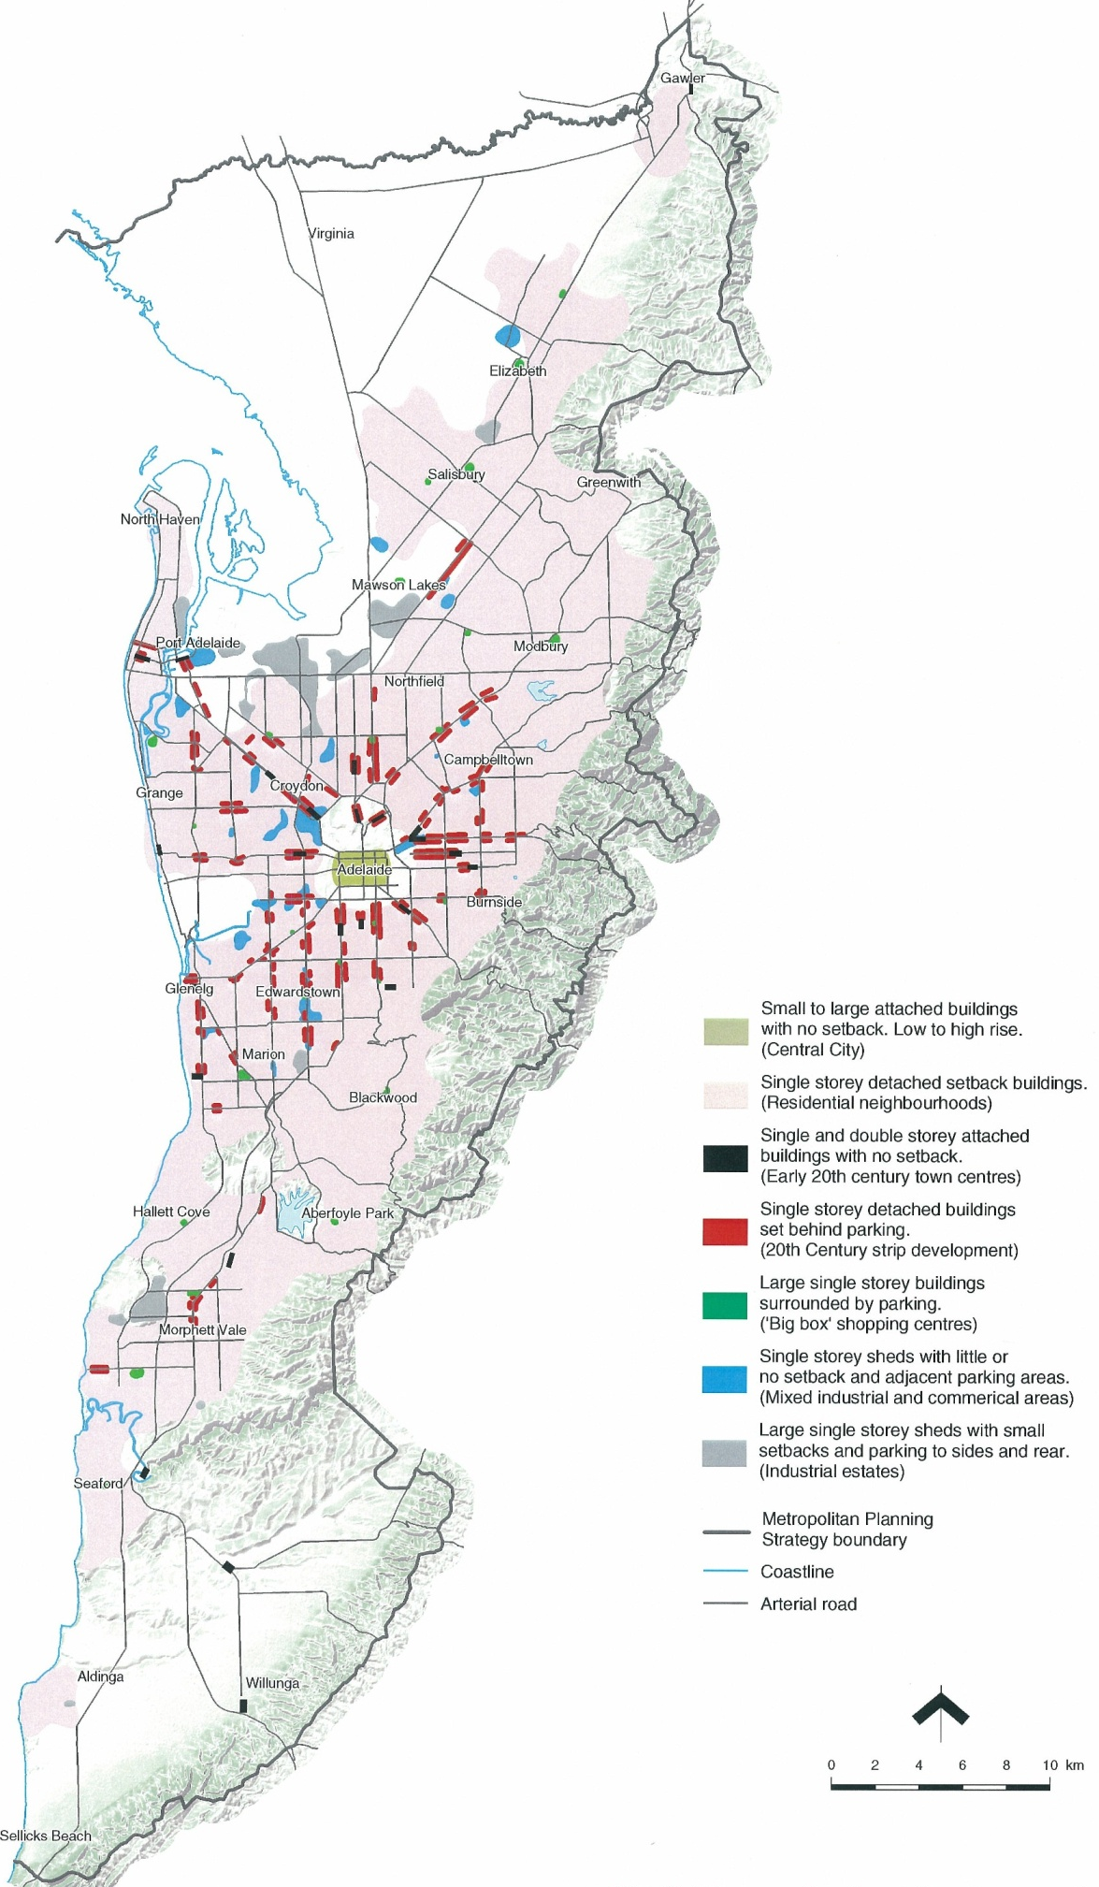

Building form in metropolitan Adelaide, 2003
Appendix: A chronology of significant events in the evolution of the metropolitan area's structure and character

Before 1836 Occupation of the Adelaide Plains for at least ten thousand years by Aboriginal groups. Population approximately 300.
1836 Colonel William Light chooses a site on the east side of the Gulf St Vincent as the site for the capital of the new British colony of South Australia, with the main settlement on the River Torrens, ten kilometres inland and a subsidiary settlement at the harbour on the Port River.
1837 Survey of North and South Adelaide into 1040 one-acre blocks for selection and auction.
1839 Survey of the District of Adelaide, from Grand Junction Road to Sheidow Park, predominantly into 80 and 134 acre sections. Survey of Glenelg.
1840 Rural sections in the District of Adelaide released to the market. Speculative buying and subdivision of rural sections creates about thirty small villages along traffic routes or near water supplies including Port Adelaide, Hindmarsh, Prospect, Thebarton, Mitcham, Unley and Kensington. Population approximately 6,000.
1840? Glen Osmond Road reserved. Survey from Sheidow Park to Seflicks Beach, including the Southern Vales. 1848? Laying out of Main North Road between Grand Junction Road and Gawler. 1852 Adelaide to Salisbury railway opens. (Later extended to Gawler and Kapunda.) Adelaide terminal in parklands adjacent to North Terrace. This became and remains the metropolitan area's main rail station.
1850? Surveys of the area north of Grand Junction Road to the Gawler River. Existing roads through the Park Lands realigned and new roads created, including a new road between King William Street and O'Connell Street (King William Road). Road reserve on the western edge of the Park Lands used for railway or other purposes.
1856 Adelaide to Port Adelaide railway opens, severing the northern end of Torrens Road.
1858 Ban in the City of Adelaide on the use of timber in new buildings for fire safety ushers in a new era of brick and stone construction, setting a pattern for suburban development.
1859 North Terrace as a precinct for government cultural and administrative institutions cemented by the construction of the South Australian Institute, now the South Australian Museum, adding to Government House and Parliament.
1860? Port Wakefield Road laid out north of Gepps Cross.
1873 Adelaide to Glenelg railway opens, terminating at Victoria Square.
1875-1882 A building boom, with massive subdivisional activity, especially in the southern and eastern suburbs.
1878-1884 Boom period for creation of horse tramways, encouraging suburban development. Lines include those extending from Adelaide to Norwood, Mitcham, Henley Beach, Parkside, Goodwood, Nailsworth, Paradise, Magill and Burnside. An economic depression and the introduction of the bicycle deflates the boom.
1883 Adelaide to Melbourne railway opens, leading to development of summer retreats at Blackwood, Stirling and Aldgate.
1891 Port Adelaide to Semaphore railway and jetty open, catering for passengers and freight using ships too large to use Port Adelaide.
Belair National Park established, the second national park in Australia.
1893 Woodville to Grange railway opens.
1900 Population 160,000.
1907 Erection of South Australia's first building higher than three storeys.
1908 The Outer Harbor opens for freight and passenger ships.
1909 Electrification of tramways begins.
1919 Adelaide population reaches 250 000 people.
1920's Private cars become a common form of urban transport in Adelaide.
1924 James Stobie invents the Stobie pole to carry electricity and telephone cables servicing the expansion of metropolitan Adelaide.
1929 Glenelg railway converts to an electric tram service.
1930's? Creeks channellised.
Torrens Outlet dug to drain the marshes between the Port River and the Patawalonga River.
1936 South Australian Housing Trust established to build low-cost housing for industrial workers.
1939 Adelaide population reaches 325 000.
1938-1940 Adelaide - Glenelg road rebuilt with dual carriageways, plantation and bike path and renamed Anzac Highway.
1940 Birkenhead Bridge opens.
Rapid industrialisation to make war equipment and supplies.
1940's Establishment of Defence Science and Technology Organisation at Edinburgh, and closure of the public road network throughout the site.
1950's Motor cars become the predominant mode for urban passenger travel in Adelaide as car ownership becomes nearly universal among adults.
1953? Realignment of major roads around Elizabeth.
1954 Construction commences of dwellings in the satellite town of Elizabeth.
1955 Adelaide Airport opens.
Act to limit subdivision of land in the foothills of the Mount Lofty Ranges, due to cost of providing water and sewers.
1959 Adelaide's population reaches 600 000.
1960 1,150 acres acquired at Humbug Scrub for a future national park.
1962 Adelaide's first metropolitan plan released. The Report on the metropolitan area of Adelaide, 1962 plans for the growth of a linear city spreading to Gawler in the north and Sellicks Beach in the south, and six new regional centres.
1967 Establishment of the Hills Face Zone along the western slopes of the Mount Lofty Ranges, largely preventing further suburban development in the zone.
1968 Metropolitan Adelaide Transport Plan (MATS) proposes a system of 98 kilometres of expressways. Land acquisition causes urban blight in some inner suburbs.
Conversion of wetlands at West Lakes into residential estate begins.
1970 South Road between Days Road and Torrens Road constructed.
Development of Noarlunga by the SAHT.
1972 The South Australian Land Commission established to supply low-cost urban land to the market.
New Stirling to Verdun freeway opens.
1973 Festival Theatre opens.
1976 Rundle Mall opens between King William and Pulteney Streets.
1985 Work begins at Golden Grove, a privately developed group of suburbs.
1989 The twelve-kilometre Adelaide - Modbury O-Bahn begins service.
1990 Adelaide's population passes 1 000 000.
1997 Southern Expressway opens.
2000 The Heysen Tunnels open.
2002 An urban containment boundary around the Adelaide metropolitan area comes into interim effect.

