Nathan Alexander

Design of the Bourke Street Mall
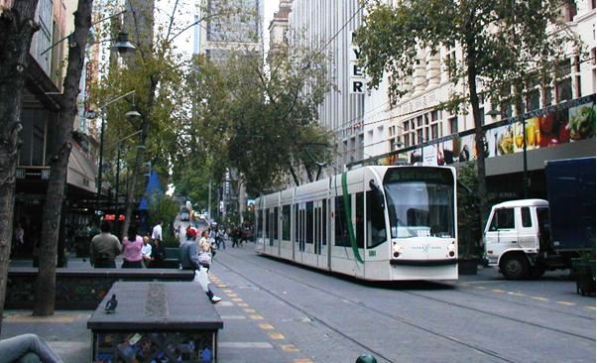

January 2005

www.alexanderurbanism.com

This article was published in Price Tags Issue 56, January 19th, 2005. Price Tags is an email magazine from Gordon Price, a Vancouver urbanist. In Issue 55 Gordon had published an article about Melbourne that mentioned the Bourke Street Mall. This was a response to that article.

I was working as an urban designer for the City of Melbourne in the early 1990's, and led the design process for the Bourke Street Mall as it is currently configured. The first main driver for change was the need to replace the paving. The bricks were breaking up, due to the vibration from the trams and the turning movements of service vehicle tyres, and becoming a major trip hazard. The second driver for change was the upgrade of the adjoining street, Swanston Street. The major retailers in Bourke Street wanted Bourke Street to remain the city's best retail address.
Bourke Street Mall is 30m wide and 200m long, and was the first pedestrianised street in central Melbourne, created in temporary form in about 1979. It was made permanent in 1982, renovated in 1994, with plans for yet another renewal underway.
The mall had been conceived as an isolated pedestrian island in a sea of vehicle-dominated streets. By the early 1990's, we were seeing it as a major part of the city-wide pedestrian network, a part that should carry through the suite of materials and furniture used throughout the strong, formal grid of central Melbourne. The other main issues with the earlier design were:
- Social - no space for major pedestrian gatherings
- Facilities - no stage, few power outlets
- Furniture - generally hard to maintain or replace, not enough seats, seats hard to clean
- Views - the low-hanging foliage from the virtually evergreen Yunnan Poplars blocked long views out of and through the mall, and the solid furniture blocked the tram drivers' views of small kids
- Ambience - the styling looked dated and the poplars made the place dark
- Movement - the planter box-seat units blocked some of the major pedestrian desire lines across the mall between major retailers
In the stakeholder and public consultation, the desire for a 'real mall' led some people to call for the trams to stop either end of the mall. 'Surely people can walk one block, or take tram services on alternative routes?'
The tram operators pointed out that this was one of the major east-west routes, that rerouting the trams would mean new track and multi-millions of dollars, that some people couldn't walk the distance, and the rest mostly wouldn't want to. Anyway, a lot of the passengers wanted to go to Bourke Street.
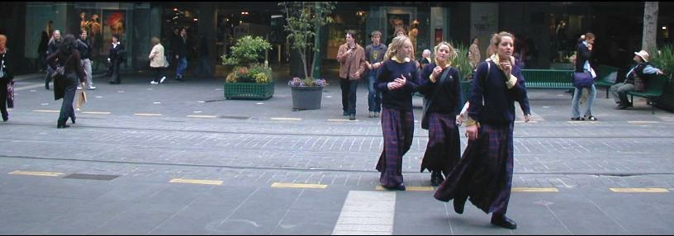
Meanwhile, the department store operators decided that having trams dropping customers at their doors was worth more than having more young people hanging around there watching buskers. The City decided that the mall's main role would remain as catering for through tram and pedestrian traffic, and we'd make the best of it.
So, the new design:
- Used stone paving to give a long life and a sense of quality
- Added seats in sun and shade, under trees and in the open
- Used more open furniture, away from major desire lines, that could be replaced or repositioned easily if needed
- Pruned off the lower limbs of the trees to add light, create a higher 'ceiling' and open up longer views
- Added platforms either side of the tram tracks to be used as minor stages, with the opportunity for major events to halt the trams and build a temporary stage over the tracks

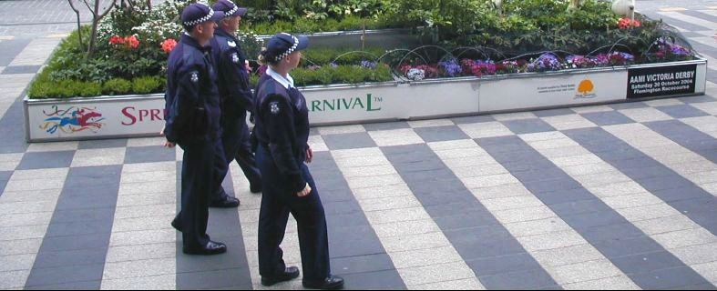
I'd draw two main lessons from this experience. Firstly, it's easy to conceive of city streets being either roads or malls. In fact, all city streets cater for a wide variety of functions, such as through movement, deliveries, window shopping and parades. Any of these functions can be prohibited, allowed or encouraged, so there can be an infinite variety in the mix of street functions (as there is!).
So rather than thinking about having a vehicular street or a pedestrian mall, it's more useful to think about the optimal mix of uses and allocation of space within the unique set of circumstances presented by each street. Admittedly, that's a harder message to communicate to the public, but not impossible. Secondly, because the Bourke Street Mall is still a street, and has through traffic (of trams and peds) as its prime functions, it is unreasonable to expect it to perform well as a city square. Cities need both streets (ped, private motor vehicle, tram, combo, whatever) and squares to have a good public life. Just as you don't expect your home's corridor to make a good living room, we shouldn't expect our malls to make good squares. Mind you, they can be pressed into service in that way, and Bourke Street Mall is, because there is no square within the retail heart.(Although Melbourne now has several immediately outside that area.) However, the mall is still fundamentally a street. Lessons for Vancouver? The presence of transit does mean the city won't have a pedestrian-only mall. So what? The mall can still be made a good space for pedestrian through traffic, and to sit and watch the world go by. Somewhere else in the retail heart can be turned into a square where more people can gather.
All images by Gordon Price.

