Nathan Alexander

Six qualities to assess urban form
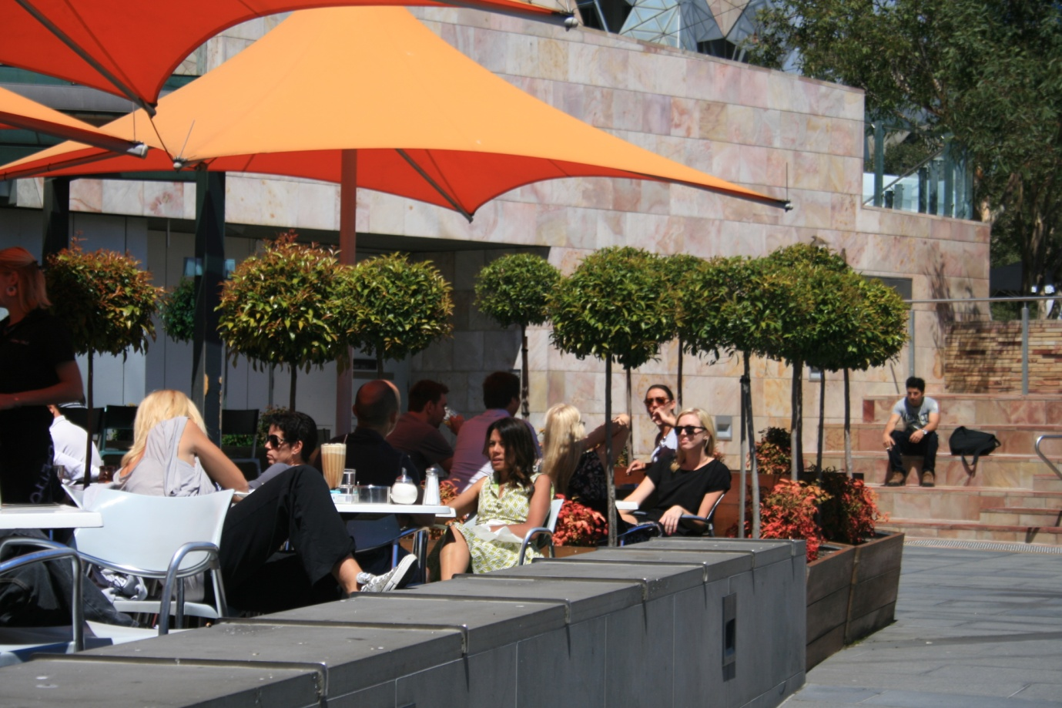

Extract from "Squeezing Spread Cities: improving the energy efficiency of large cities", an unpublished masters thesis.
October 1990

www.alexanderurbanism.com

Responsive Environments is an approach to urban design based on maximizing choice for the users of urban environments. It is widely accepted as current good urban design practice, at least in the Anglo-Celtic world. The authors state:
...the built environment should provide its users with an essentially democratic setting, enriching their opportunities by maximising the degree of choice available to them. We call such places responsive.
They believe that the political ideal of maximizing choice is manifested in the built environment through the key qualities of:
Permeability
Only places that are accessible to people can offer them choice. Permeability measures the degree of choice in the number of routes to a place.
Vitality
To take advantage of the range of routes available people must feel safe. This often takes the form of the presence of other people.
Variety
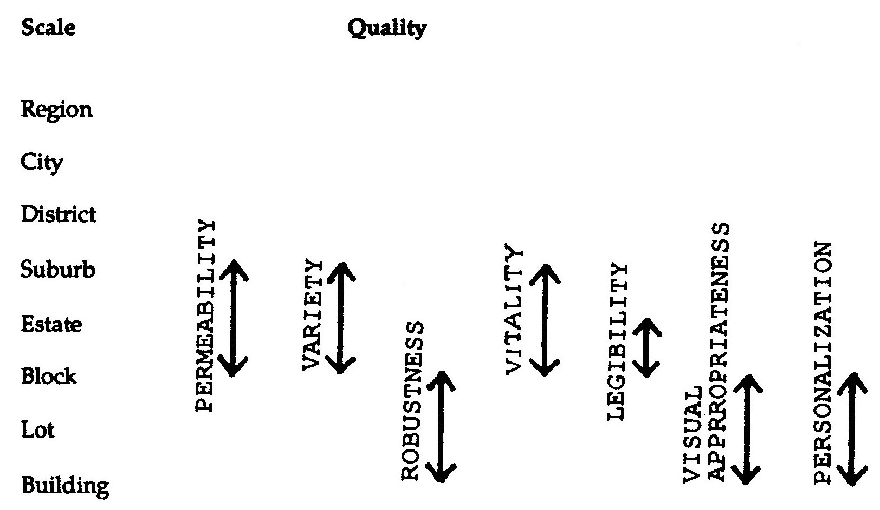Responsive Environments qualities: scales of applicability

The above qualities are useless by themselves. Alternative safe routes need to offer a choice of experiences.
Legibility
To use the choices available, people must know the choices on offer and understand the layout of the spaces.
Robustness
Places, and especially buildings, which can be used for many different purposes offer their users more choice than places whose design limits them to a single fixed use.
Visual Appropriateness
People interpret what they see and give places meaning. A place that is visually appropriate to its users will help people be aware of the choices available to them.
Personalization
Places can offer people the choice to leave their own mark.
The Responsive Environments qualities are at the local end of the scale of the physical elements of a city, as befits a manual on urban design. However, to develop a range of qualities suitable to assess a whole city as an integrated system, these qualities need to be adapted.
Restated to apply from the regional scale down to individual spaces, the Responsive Environments qualities take the following form:
Accessibility
Only places that are accessible to people can offer them choice. Accessibility measures the ease with which people can get to where they want to go.
Security
To take advantage of accessible facilities people must feel safe. In public places this often requires the presence of many other people.
Variety
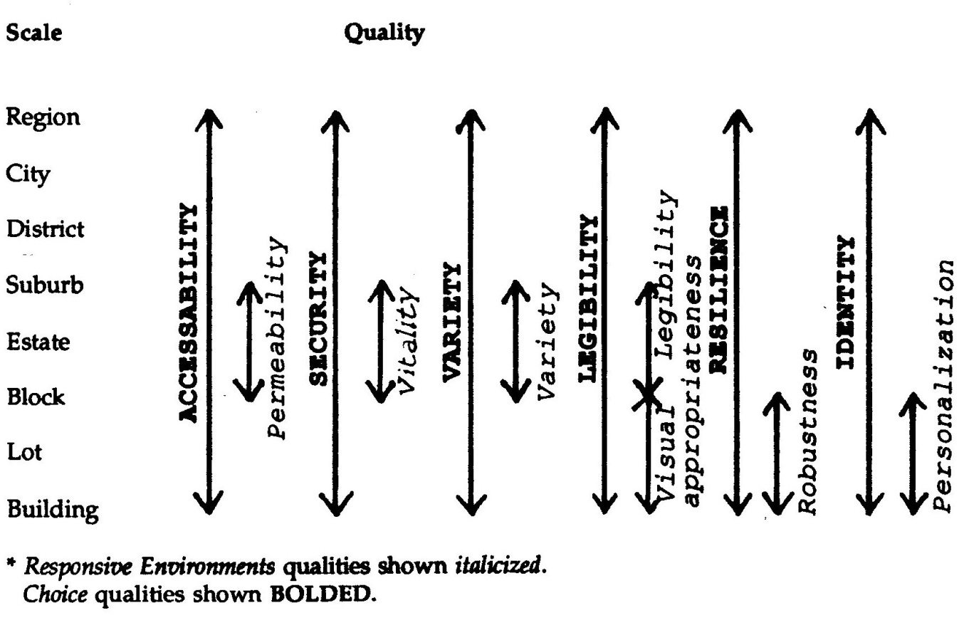 Scale of application for qualities to maximise choice

The above qualities are useless by themselves. Accessible, safe facilities need to offer a choice of functions and experiences.
Legibility
To use the choices available, people must be able to interpret what each facility offers and be able to comprehend where in space it is found.
Resilience
To minimize risk from the uncertainty of the future a facility must be able to accommodate a number of uses at any one time or be able to be converted to others in the future.
Identity
People need to know that they can influence their world, that they have power over their lives. As marks on the physical environment help to provide meaning, a facility must be able to bear the signatures of the people who use it.
These six new qualities make a set suitable to apply at all scales of a city. The figure below shows how these qualities of choice relate to those of Responsive Environments.
Accessibility can be contrasted with mobility. Increasing mobility means catering for the demand for movement In terms of contemporary urban form that largely means decreasing impediments to the rapid movement of cars. Planning for mobility sees more movement per se as a good thing. Accessibility, on the other hand, means being able to get to the facilities that people wish to use.
The less movement and transport technology interposed between the person and the facility the more accessible the facility is. The present preoccupation with planning mobility addresses the wrong end of the problem. "Urban mobility could be described as a measure of how often the planning of a city has imposed the barrier of distance between its citizens and their desired activities." Planning for accessibility sees altered land use distribution and emphasis on low-tech transport as a desirable goal.
Resilience is a key to how useful a facility is likely to be over time; as Bentley and others state:
We cannot predict the likely changes in use which might occur during the expected life of a building: even in the short run, predictions of this kind are notoriously unreliable.
This is as true for outdoor spaces and transport networks as it is for buildings.
For buildings they suggest the best strategy for maximizing resilience is to keep buildings low and shallow, and provide good possibilities for access between the inside and the outside at short distances. For public spaces the strategy is to:
design settings which, as far as possible, enable a variety of activities to co-exist in the public realm without inhibiting each other.
Identity at the smallest level means the ability to personalize the spaces that one uses, especially one's dwelling. At larger scales it means the ability of people to instantly recognize a place as unique. It also means the image that a place conveys to the outside world.
These quantities of choice are not in themselves conflict free. The block structure of Manhattan provides an example. The east-west Streets are not far apart, but the north-south Avenues are spaced about three hundred metres from each other. This creates very narrow, long blocks that have the effect of keeping the Streets relatively quiet while concentrating activity onto the Avenues. This maximizes variety, but at the cost of permeability.
The above six qualities give us criteria with which to assess urban form. To maximize choice, to provide a "democratic setting", elements of a city, from a courtyard up to the whole region, should provide a high degree of each of these qualifies. Assessing the degree to which an environment provides the qualities of choice is difficult because qualities by definition are not quantifiable. To make assessment even more difficult, these qualities are concerned with how people perceive environments, not what they are. Determining that every building in a street is different in some way and thus offers variety is useless if the people using the street perceive all the buildings as monotonous. Perceptions of a place and people's interests in it will vary according to class, gender, income, ethnicity, and so on.
Probably the easiest and most effective tool for assessment is comparison with existing environments. The interests that are being served by a place are usually clear to see by the people and land uses there. Users and potential users can judge the qualifies of real spaces much more easily than proposed ones.
Inevitably when a part of a city is being redeveloped trade-offs occur between fulfilling the interests of one group and those of another: this is a large part of the art of urban design! The values placed on these choices is inevitably subjective: value-free judgements are impossible.
What is possible is to make dear who wins and who loses, and how much of their needs and desires are being met by a proposed or existing environment.

Bentley and others, 1985, Responsive Environments: a manual for designers Architectural Press, London
Ibid, p. 9
Deborah White, 1980 Discussion in CIB, 1980 Energy conservation in the built environment Session 4, p.22
Bentley and others, as above, p. 57
Ibid, p. 60

