**Nathan Alexander**

**A short history of Flinders Street Station**

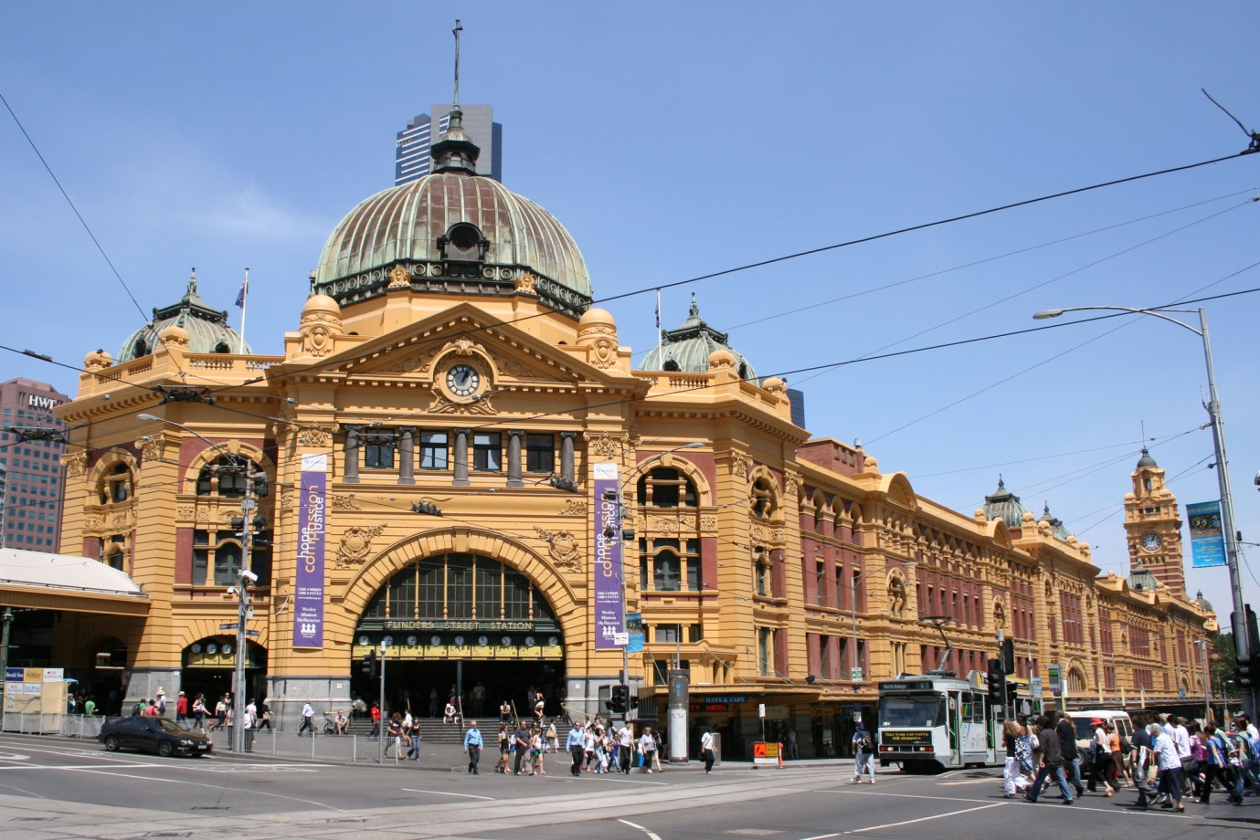

Extracted and adapted from a report prepared for the Victorian Department of Transport.

June 2011

**www.alexanderurbanism.com**

The location for Flinders Street Station, the hub of Melbourne’s passenger rail network, was fore-ordained by Robert Hoddle’s decision in 1837 to lay out the township of Melbourne parallel to a stretch of the Yarra River. A year before, John Batman had sailed up the river and chosen as the site for his ‘village’ the first high ground upstream from the river mouth, conveniently where low falls separated fresh water from salt. Hoddle laid out the street grid on this site. It was between three hills, Batman’s, Flagstaff and Eastern, over ground gently sloping towards a gully near the centre. The central street in Hoddle’s grid, Elizabeth Street, overlaid this gully. The track across the river and to the south, which later became St Kilda Road, ran on high ground just to the east of the South Melbourne swamp and another swamp that became Albert Park Lake. This connected to the central city grid of streets most naturally at Swanston Street.

With the Gold Rushes of the early 1850’s, the ocean-going ships bringing immigrants and freight docked at Sandridge, now Port Melbourne. When the first rail service in the colony began in 1854, it ran between the pier at Sandridge and crown land just south of Elizabeth Street, by then the premier street in the settlement. The station soon extended east to St Kilda Road. In 1857, a new line was opened between Princes Bridge and Richmond, running over open ground at the edge of the river flats. This line was later extended to Hawthorn and Brighton. In 1859 a line was established between Spencer Street and Williamstown, skirting around the West Melbourne Swamp. By 1892 all these lines were connected.

By the 1880’s Melbourne had become a large and grand metropolis. For almost two decades from 1883 plans for a grand station at Flinders Street befitting the grand metropolis were prepared but not executed. Finally a design by two Railways Department employees, Fawcett and Ashworth, was carried through, the result of a competition in 1899. The original design for a new station and station yard had ten platforms, two subways, a three storey building on Flinders Street, and a roof over the platforms.

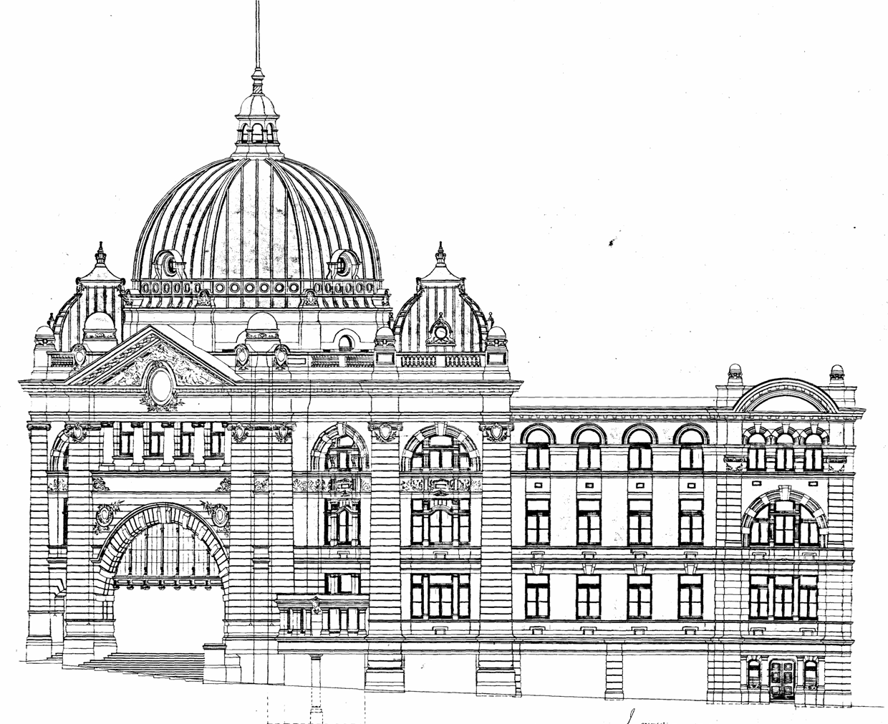

*One of the original drawings of the proposed elevation of the station's Administration Building, c. 1905*

*Plan of the station yard and the Administration Building, c. 1905*

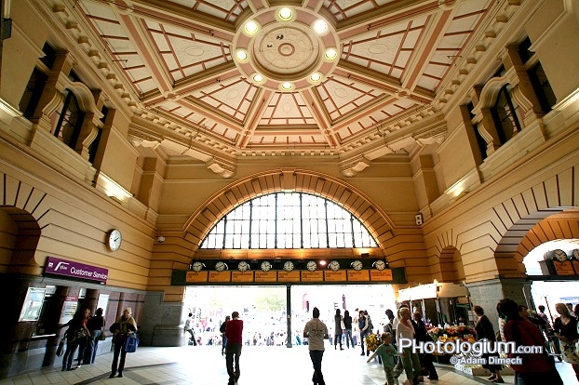

*The grand interior space of the booking hall, 2011*

By the time the construction was completed in 1910, the station building had gained an extra level and the platforms had lost their roof. The extra storey was justified to parliament as office space whose leasing would help defray the expense of the station construction.

Instead of being leased out, much of the space in the new building was used by the newly established Victorian Railways Institute. This club for employees and ex-employees included a lecture theatre (later the ball room), a gymnasium, billiard room, games room library and classrooms.

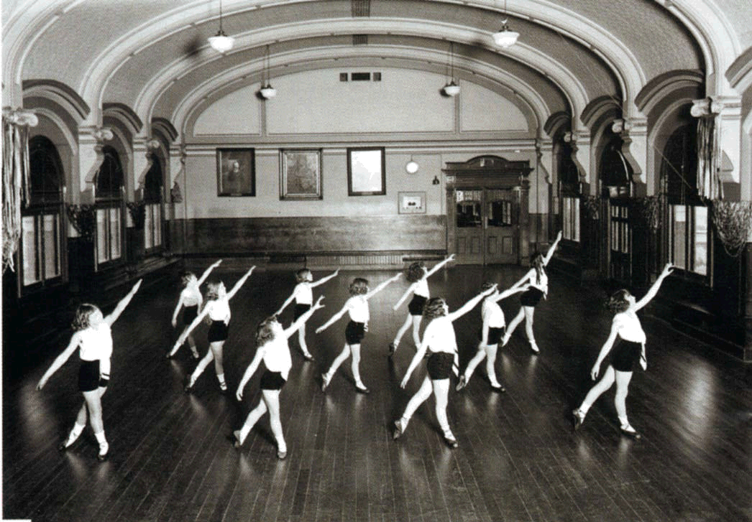

*A ballet class in the ‘ball room’, c. 1940.*

Almost from its opening, claims of congestion dogged the station, along with actions to improve capacity and claims that the station was ‘the busiest in the world’. Electrification of the suburban lines was completed in 1923, making the trains using Flinders Street Station much quieter and cleaner and giving potential for through-routing. This substantially increased the station’s capacity.

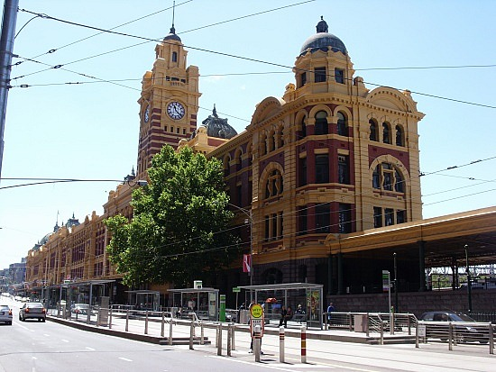1926 saw the first call for an underground line through the northern part of the central city to relieve congestion at Flinders Street. The Melbourne Underground Rail Loop did eventually occur, opening in 1981. For almost a century a tidal flood of commuters had washed out and in of Flinders Street Station each weekday. Their spending as they moved between the station and their work places had created the concentration of shops in the streets, lanes and arcades between Swanston and Elizabeth Streets. After the Loop opened, the commuter flow dispersed.

*A view of the Administration Building looking east along Flinders Street, 2011*

**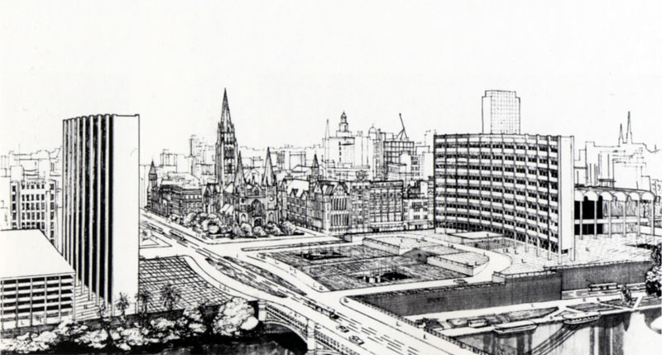***A proposal for Flinders Street Station and Princes Gate Station c. 1962.*

Substantial proposals to redevelop the station site were announced in 1959, 1962, 1967, 1972, the mid 1970’s and 1986. They all lapsed. Over the road the Princes Gate Station was rebuilt in 1965 and surmounted by two office towers. These were later voted by the public as the ugliest buildings in Melbourne.

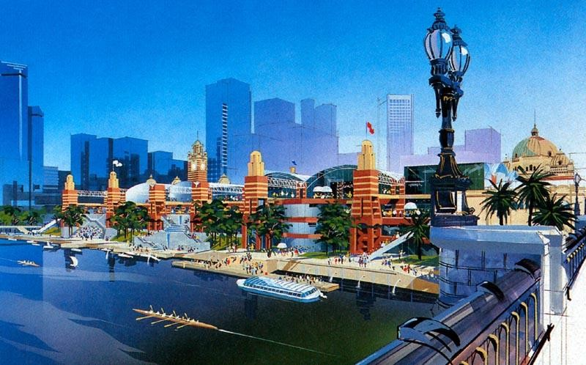

*Artist’s perspective of the shopping centre proposed by Haysom-Custom Credit, 1986*

The station was first officially recognised for its heritage values in 1974, being placed on the Victorian Government Buildings Register. In 1996 this became the Victorian Heritage Register. The platforms, concourse roof, and the formerly public parts of the Administration Building were assessed as of primary conservation significance, while most of the remainder was assessed as ‘contributory’.

The swampy area across the river from the station had long been covered by factories and warehouses. In 1968 the National Gallery of Victoria opened its doors on its current St Kilda Road site, followed in 1982 by the Melbourne Concert Hall, now Hamer Hall. This began the redevelopment of the area into a mixed use area with high rise residential and office towers. In 1983 a new walkway opened the north bank of the river to public use. Ten years later various public realm works accompanied the opening of Southgate, including the new pedestrian bridge (the ‘Coat Hanger’) and the division of the Elizabeth Street subway into paid and unpaid corridors. The next year the Flinders Street Station concourse was refurbished and Clocks Tabaret established in the former mail room by the Yarra.

Long-mooted, the Jolimont rail yards were finally roofed with the construction of Federation Square in the early 2000’s, after the rationalisation of rail tracks from more than forty to twelve, and the demolition of the unloved Princes Gate towers.

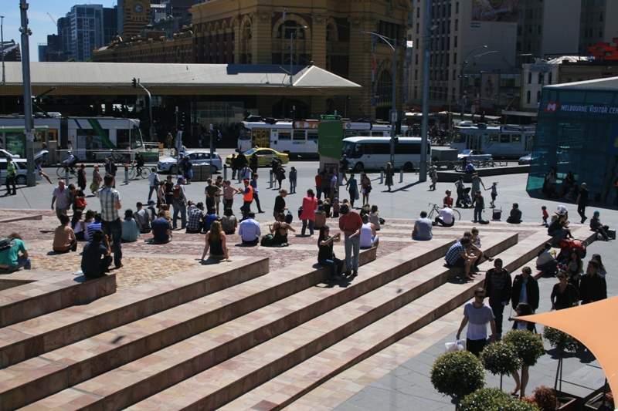

*Part of Federation Square, with Flinders Street Station in the background. 2012*

Today, as the central city has expanded across the river, Flinders Street Station is more central than ever. It is on the doorstep of many of the city’s key public spaces, including Swanston Street, Federation Square and the Southbank Promenade, and is extremely well connected to the tram network through the Federation Square stop and the Elizabeth Street terminus.

**Appendix: A chronology of the development of Flinders Street Station and its locale**

1836 Batman chooses the site for a ‘village’ – the first high ground upstream from the mouth of the Yarra, at the point where low falls formed a barrier between fresh water and salt water.

1837 Hoddle lays out a grid of streets parallel to a stretch of the Yarra River and centred around a street overlying a creek line (Elizabeth Street).

1854 Victoria’s first rail line, running between Port Melbourne and the southern end of Elizabeth Street, begins operation. Flinders Street Station is a two storey building opposite the end of Elizabeth Street.

1857 The new rail line running between the new Princes Bridge Station, on the east side of St Kilda Road, and Richmond begins operation.

1866 Two culverts are excavated under St Kilda Road to link Flinders Street Station and Princes Bridge Station.

1877 A third platform is opened at Flinders Street Station.

1881 A clock tower is erected at the station terminating the view along Elizabeth Street.

1882 Thomas Bent, as Minister for Railways, tables the Railways Act 1882. This act allocates funds for a new central railway station for Melbourne at Flinders Street, a new Princes Bridge, and viaducts to link Flinders Street Station and Spencer Street Station. The act is passed by parliament

1883 A design competition for a new station at Flinders Street is won by William Salway. It included one and two storey Italianate buildings stretching 900 feet (approximately 300 m) along Flinders Street, straddling St Kilda Road. It is not implemented.

1885 Melbourne’s first cable car line opens in Flinders Street, running at night to move goods between Spencer Street Station and Flinders Street Station.

1888 A grand bridge over the Yarra is opened on the alignment of Swanston Street to replace the low-level 1851 bridge. It is named ‘Princes Bridge’. St Kilda Road between Princes Bridge and Flinders Street is raised to accommodate rail traffic under the roadway.

1880s An extensive system of rail lines is laid through and beyond the Melbourne metropolitan area, most terminating at Flinders Street. An extensive network of tram lines is laid throughout the metropolitan area, many using a route along Swanston Street and St Kilda Road.

1880s to 1970s Concentrated pedestrian flows moving from and to Flinders Street Station lead to a high density of retailing, lanes and arcades in the street blocks bounded by Swanston and Elizabeth Streets.

1890 The Railways Department proposes a new station running from Queen Street to Russell Street. The proposal lapses.

1892 The viaducts between Spencer Street Station and Flinders Street Station are completed.

1896 The Railways Department prepares a plan for a new station between Elizabeth Street and St Kilda Road, with six platforms roofed with corrugated iron and subways on the Elizabeth Street and Degraves Street alignments. It is rejected by a parliamentary standing committee, partially for not accommodating expected future growth.

1899 The Railways Department submits a new plan for a new station to the parliamentary standing committee. This plan has ten fully roofed platforms and two subways, and a three storey building running between Swanston Street and the viaduct. The committee calls for a competition to be held for the design of the Administration Building.

1900 The Railways Department’s James Fawcett, architect, and HPC Ashworth, engineer, win the competition to design the Administration Building.

1902 The subway under the station aligned with Degraves Street opens.

1904 Various alterations are made to the Administration Building design, including the addition of a fourth storey.

1905 The laying out the station yard as per the 1899 design is completed.

1909 The Railways Department gives a 34 feet (11 metre) strip of land beside St Kilda Road to the City of Melbourne to provide space outside the station for cab standing. The clock tower and clock on the Elizabeth Street alignment are completed.

1910 The Flinders Street Station Administration Building completed. The Victorian Railways Institute is established, based in the third floor of the building. The roofing of the platforms is deleted for cost reasons.

1913 The Victorian Railways Department claims Flinders Street Station is the ‘busiest in the world’.

1923 Electrification of suburban lines completed, allowing through-routing of trains at Flinders Street Station.

1926 Mr S S Soame proposes an underground rail tunnel between Spencer Street Station and Flinders Street Station via Little Latrobe Street to deal with congestion at Flinders Street Station.

c.1935 The lecture room is converted to a ballroom.

1949 A proposal to rejuvenate the Administration Building and roof the station yard is rejected.

1954 ‘Campbell Arcade’, a subway constructed by the City of Melbourne under the southern end of Degraves Street, links into the ‘Central Subway’ under the station.

1959 A proposal is prepared to redevelop the site for a new station, town hall and city square. It lapses.

1960s The Railways Commissioners decide that the station should be demolished and rebuilt. Proposals to redevelop the site include a skyscraper, a five storey car park, and a scenic drive along the Yarra bank.

1962 The Minister for Transport and HKJ Pty Ltd sign an agreement for a £30 million redevelopment of the station that would have resulted in the demolition of the clock tower and replacement with an office building up to 60 storeys high.

1965 Princes Gate Station is reconstructed as a terminus for the Clifton Hill group of lines, with two office towers above.

1967 Meldon Properties Pty Ltd, a large property development company, acquires an option to develop space over Flinders Street Station for a shopping plaza and twin office towers. The dome and clock tower are kept as part of the design. Strong opposition sees this proposal lapse in the 1970’s.

1968 The National Gallery of Victoria opens its new premises in St Kilda Road.

1972 Victorian Premier Sir Henry Bolte unveils a plan to bridge 11 hectares of Flinders Street Station and the Jolimont rail yards for a complex of shops, offices, theatres and other community facilities.

1972 The National Trust of Australia (Victoria) classifies the station as an important heritage item.

1973 Flash flooding along Elizabeth Street floods many basements.

1974 Flinders Street Station is included on the Victorian Government Buildings Register.

c. 1975 Proposal by unknown proponents for one office tower and three mid-rise office buildings on the station site. (“Doha on the Yarra”.)

c. 1976 Proposal by Lend Lease for development over Flinders Street Station platforms.

c. 1976 Proposal by the State Government (?) for three office towers over Flinders Street Station platforms and station yard.

1981 The Melbourne Underground Rail Loop opens, dispersing the previous pedestrian concentration and extending Melbourne’s retail core to Latrobe Street.

1982 Melbourne Concert Hall (later renamed ‘Hamer Hall’) opens on St Kilda Road

1980s The industrial area on the south bank of the Yarra is redeveloped into a high density mixed use area.

1983 The Ministry of Transport refurbishes the station. Works include opening up the concourse, installing an escalator to Platforms 2&3, and making a walkway along the north bank of the river.

1986 Flinders Street Festival Marketplace Pty Ltd is given an option to construct a ‘festival market place’ in the air space over the tracks. This is abandoned in 1991. The only part of the agreement that is constructed is the renovation and re-leasing of the Banana Alley vaults.

1993 A new footbridge is constructed over the Yarra and the Elizabeth Street underpass renovated and divided into paid and unpaid corridors. Swanston Street is recognised as the city’s ‘civic spine’ and prioritised for green modes of transport.

1994 The Victorian Government plans to use Flinders Street Station as the hub for all suburban, country and interstate trains. The St Kilda line replaced with light rail and Platform 11 closed. The exterior facades of the station are repainted and the first floor of the Administration Building is refurbished and used as office space for PTC staff. The concourse is refurbished and the Clocks Tabaret established in the former mail room by the Yarra.

1996 The listing of Flinders Street Station on the Government Buildings Register is transferred to the Victorian Heritage Register.

1990s Rail lines in the Jolimont Rail Yards are rationalised from more than forty lines to 12. Tourism Victoria proposes a major new hotel over the Flinders Street Station platforms with the Administration Building as the entrance.

1997 The concourse, platforms, subways, public amenities, booking areas and retail outlets are upgraded.

2002 Federation Square is opened after the Princes Gate station and the Gas and Fuel buildings are demolished.

2004 R Corporation proposes to develop a series of low-rise buildings over the station yard.

2005 The Committee for Melbourne proposes that the western part of the Administration Building be used as a ‘creative arts incubator’ or as space for community groups.

2007 The Department of Transport and Major Projects Victoria explore using the Administration Building as a boutique hotel.

2009 VicTrack explore developing buildings over the Flinders Street frontage west of the Administration Building and the redevelopment of the Banana Alley vaults.